Chapter 21
The Theory of Consumer Choice
Multiple Choice
1. The theory of consumer choice provides the foundation for understanding
a. the structure of a firm.
b. the profitability of a firm.
c. a firm’s product demand.
d. a firm’s product supply.
ANS: C PTS: 1 DIF: 1 REF: 21-0
TOP: Consumer choice MSC: Definitional
2. The theory of consumer choice examines
a. the determination of output in competitive markets.
b. the tradeoffs inherent in decisions made by consumers.
c. how consumers select inputs into manufacturing production processes.
d. the determination of prices in competitive markets.
ANS: B PTS: 1 DIF: 1 REF: 21-0
TOP: Consumer choice MSC: Definitional
3. Consider two goods, books and hamburgers. The slope of the consumer’s budget constraint is measured by the
a. consumer’s income divided by the price of hamburgers.
b. relative price of books and hamburgers.
c. consumer’s marginal rate of substitution.
d. number of books purchased divided by the number of hamburgers purchased.
ANS: B PTS: 1 DIF: 2 REF: 21-1
TOP: Budget constraint MSC: Interpretive
4. If a consumer’s income decreases, the budget constraint for CDs and DVDs will
a. shift outward, parallel to the original budget constraint.
b. shift inward, parallel to the original budget constraint.
c. rotate outward along the CD axis because we can afford more CDs.
d. rotate outward along the DVD axis because we can afford more DVDs.
ANS: B PTS: 1 DIF: 2 REF: 21-1
TOP: Budget constraint MSC: Analytical
5. If the relative price of a concert ticket is 3 times the price of a meal at a good restaurant, then the opportunity cost of a concert ticket can be measured by the
a. slope of the budget constraint.
b. slope of an indifference curve.
c. marginal rate of substitution.
d. income effect.
ANS: A PTS: 1 DIF: 2 REF: 21-1
TOP: Budget constraint MSC: Analytical
6. When the price of a shirt falls, the
a. quantity of shirts demanded falls.
b. quantity of shirts demanded rises.
c. quantity of shirts supplied rises.
d. demand for shirts falls.
ANS: B PTS: 1 DIF: 1 REF: 21-1
TOP: Demand MSC: Analytical
7. A budget constraint
a. shows the prices that a consumer chooses to pay for products he consumes.
b. shows the purchases made by consumers.
c. shows the consumption bundles that a consumer can afford.
d. represents the consumption bundles that give a consumer equal satisfaction.
ANS: C PTS: 1 DIF: 1 REF: 21-1
TOP: Budget constraint MSC: Definitional
8. Assume that a college student spends her income on books and pizza. The price of a pizza is $8.00, and the price of a book is $15. If she has $100 of income, she could choose to consume
a. 8 pizzas and 4 books.
b. 4 pizzas and 5 books.
c. 9 pizzas and 3 books.
d. 4 pizzas and 3 books.
ANS: D PTS: 1 DIF: 2 REF: 21-1
TOP: Budget constraint MSC: Applicative
9. Assume that a college student spends her income on mac-n-cheese and CDs. The price of one box of mac-n-cheese is $1.00, and the price of one CD is $12.00. If she has $100 of income, she could choose to consume
a. 15 boxes of mac-n-cheese and 6 CDs.
b. 20 boxes of mac-n-cheese and 7 CDs.
c. 10 boxes of mac-n-cheese and 8 CDs.
d. 30 boxes of mac-n-cheese and 6 CDs.
ANS: A PTS: 1 DIF: 2 REF: 21-1
TOP: Budget constraint MSC: Applicative
10. A consumer that doesn’t spend all of her income
a. would be at a point outside of her budget constraint.
b. would be at a point inside her budget constraint.
c. must not be consuming positive quantities of all goods.
d. must be consuming at a point where her budget constraint touches one of the axes.
ANS: B PTS: 1 DIF: 2 REF: 21-1
TOP: Budget constraint MSC: Interpretive
11. An increase in income will cause a consumer’s budget constraint to
a. shift outward, parallel to its initial position.
b. shift inward, parallel to its initial position.
c. pivot around the “Y” axis.
d. pivot around the “X” axis.
ANS: A PTS: 1 DIF: 2 REF: 21-1
TOP: Budget constraint MSC: Analytical
Figure 21-1
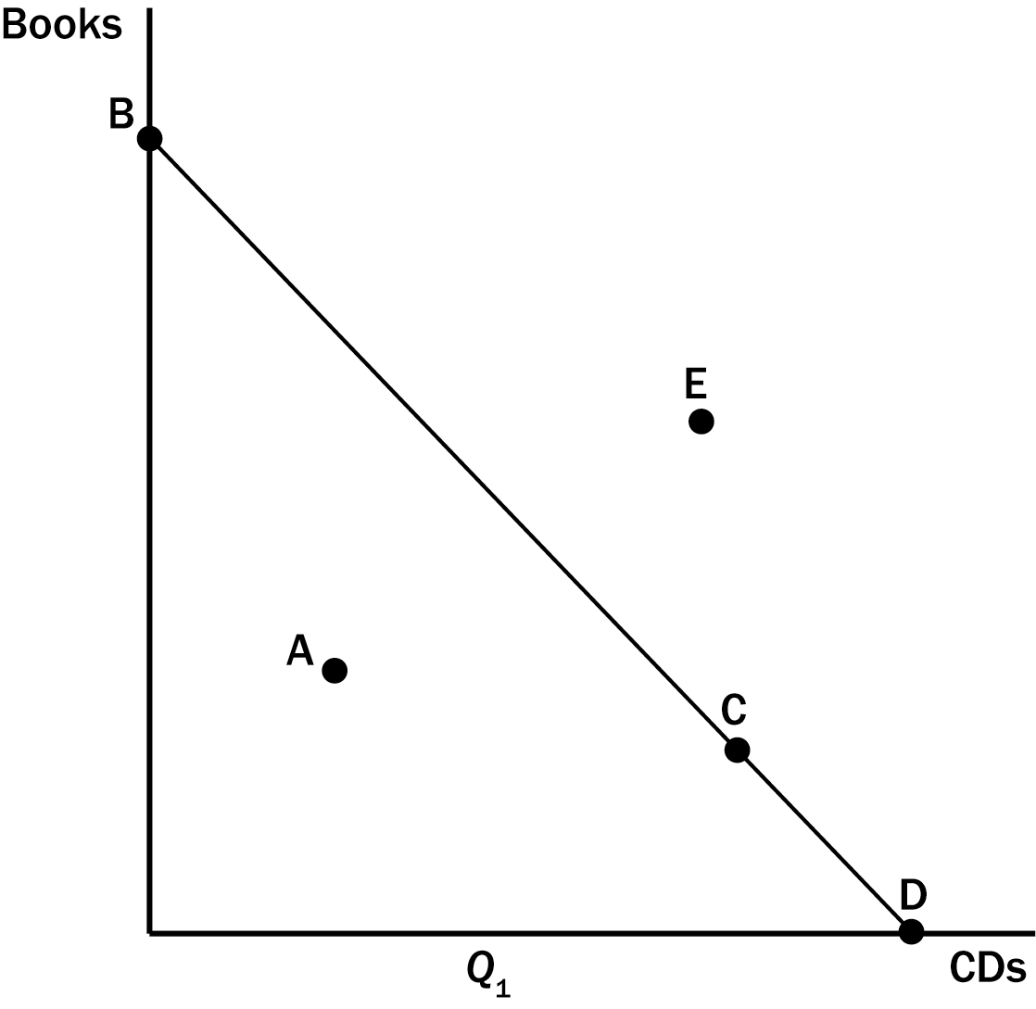
12. Refer to Figure 21-1. Which point in the figure showing a consumer’s budget constraint represents the consumer’s income divided by the price of a CD?
a. Point A
b. Point C
c. Point D
d. Point E
ANS: C PTS: 1 DIF: 2 REF: 21-1
TOP: Budget constraint MSC: Applicative
13. Refer to Figure 21-1. A consumer that chooses to spend all of her income could be at which point(s) on the budget constraint?
a. A
b. E
c. B, C, or D
d. A, B, C, or D
ANS: C PTS: 1 DIF: 1 REF: 21-1
TOP: Budget constraint MSC: Applicative
14. Refer to Figure 21-1. All of the points identified in the figure represent possible consumption options with the exception of
a. A
b. E
c. A and E
d. None. All points are possible consumption options.
ANS: B PTS: 1 DIF: 2 REF: 21-1
TOP: Budget constraint MSC: Applicative
Figure 21-2
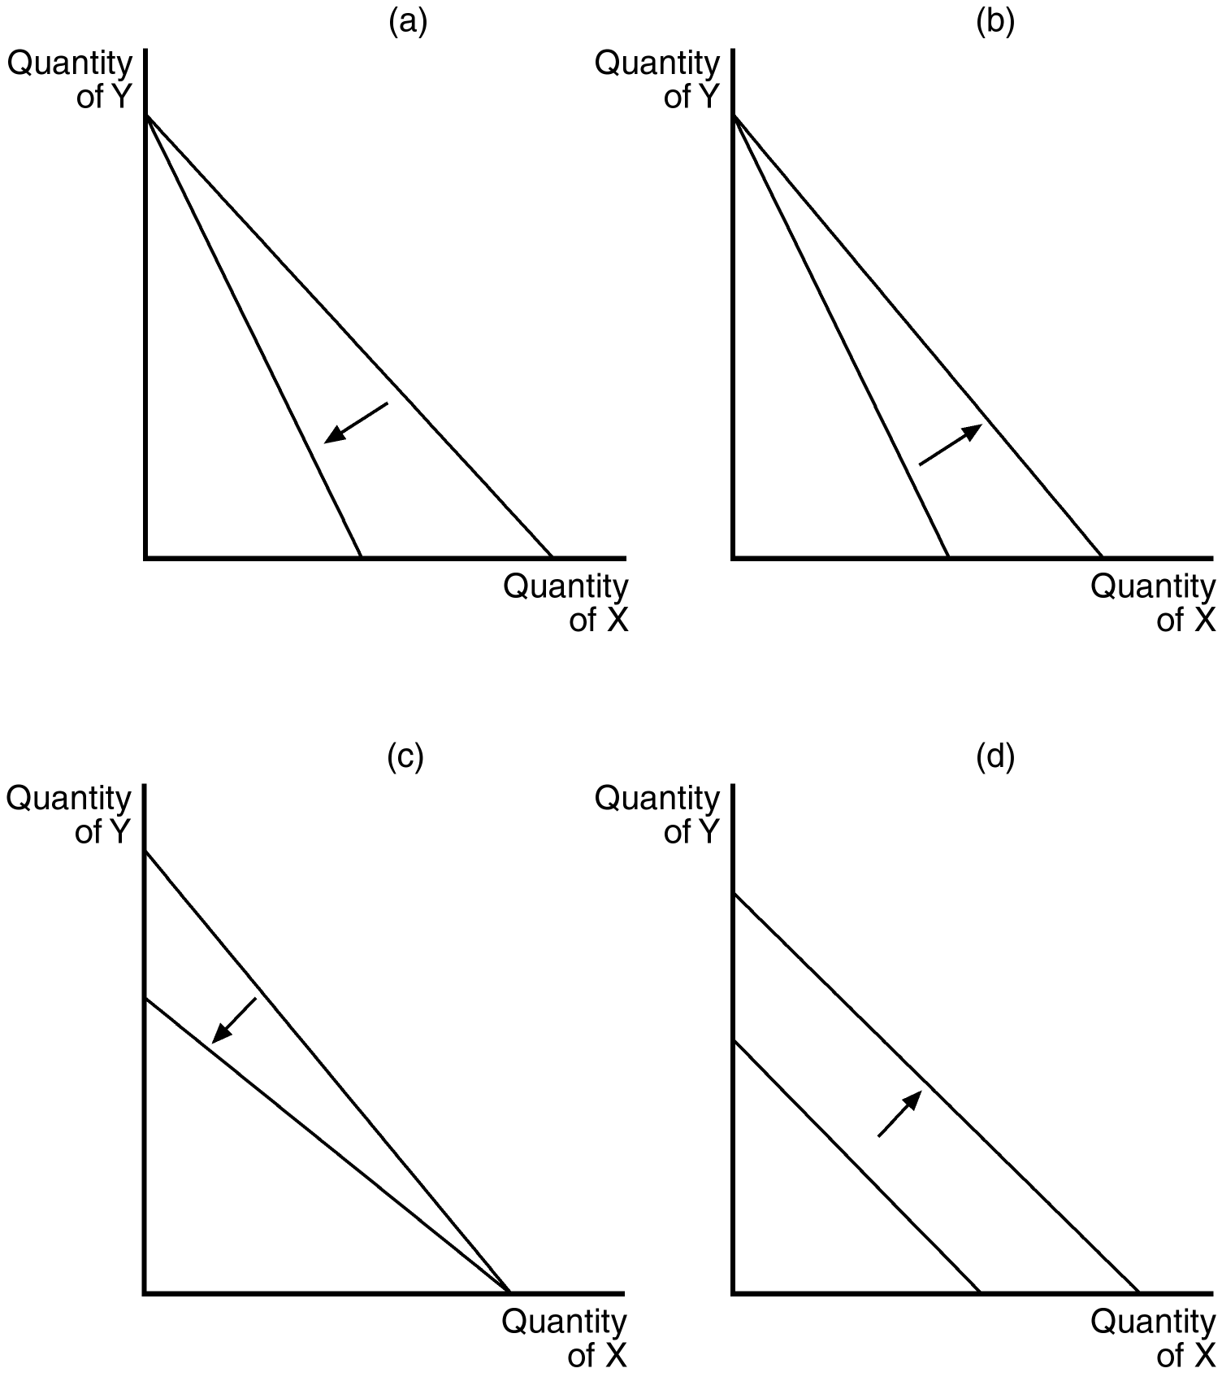
15. Refer to Figure 21-2. Which of the graphs in the figure reflects a decrease in the price of good X only?
a. graph (a)
b. graph (b)
c. graph (c)
d. graph (d)
ANS: B PTS: 1 DIF: 2 REF: 21-1
TOP: Budget constraint MSC: Analytical
16. Refer to Figure 21-2. Which of the graphs in the figure reflects an increase in the price of good Y only?
a. graph (a)
b. graph (b)
c. graph (c)
d. graph (d)
ANS: C PTS: 1 DIF: 2 REF: 21-1
TOP: Budget constraint MSC: Analytical
17. Refer to Figure 21-2. Which of the graphs in the figure could reflect a decrease in the prices of both goods?
a. graph (a)
b. graph (b)
c. graph (c)
d. graph (d)
ANS: D PTS: 1 DIF: 2 REF: 21-1
TOP: Budget constraint MSC: Analytical
18. The slope of the budget constraint is determined by the
a. relative price of the goods measured on the axes.
b. relative price of the goods measured on the axes and the consumer’s income.
c. endowment of productive resources.
d. preferences of the consumer.
ANS: A PTS: 1 DIF: 1 REF: 21-1
TOP: Budget constraint MSC: Definitional
19. The slope of the budget constraint is all of the following except
a. the relative price of two goods.
b. the rate at which a consumer can trade one good for another.
c. the marginal rate of substitution.
d. constant.
ANS: C PTS: 1 DIF: 1 REF: 21-1
TOP: Budget constraint MSC: Definitional
Figure 21-3

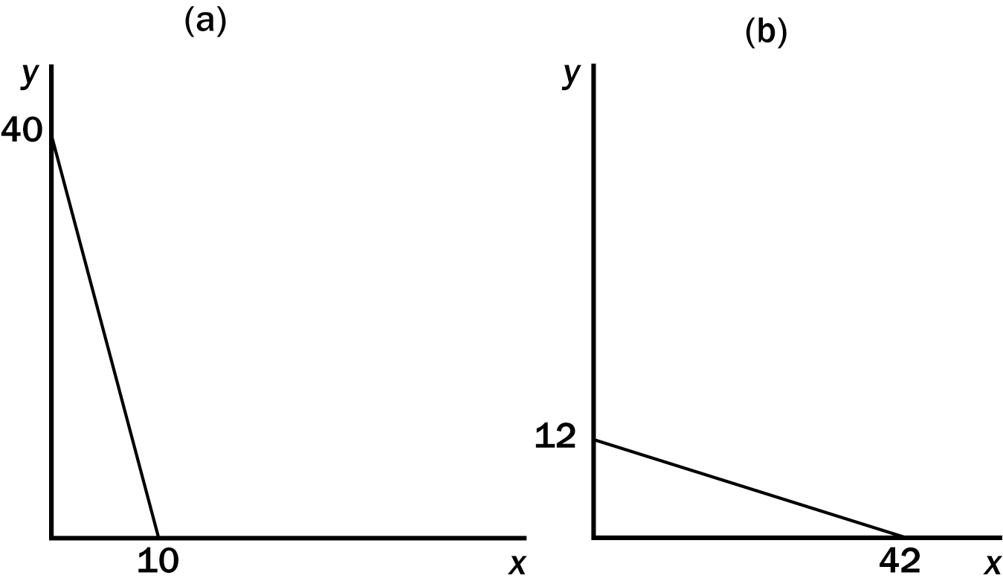
20. Refer to Figure 21-3. In graph (a), if income is equal to $120, the price of good y is
a. $1
b. $2
c. $3
d. $4
ANS: C PTS: 1 DIF: 2 REF: 21-1
TOP: Budget constraint MSC: Applicative
21. Refer to Figure 21-3. In graph (a), what is the price of good y relative to good x (i.e., P_{y}/P_{x})?
a. 1/3
b. 1/4
c. 3
d. 4
ANS: B PTS: 1 DIF: 3 REF: 21-1
TOP: Budget constraint MSC: Applicative
22. Refer to Figure 21-3. In graph (b), what is the price of good x relative to good y (i.e., P_{x}/P_{y})?
a. 2/7
b. 3/6
c. 7/2
d. 7
ANS: A PTS: 1 DIF: 3 REF: 21-1
TOP: Budget constraint MSC: Applicative
23. Refer to Figure 21-3. Assume that a consumer faces both budget constraints in graph (a) and graph (b) on two different occasions. If her income has remained constant, what has happened to prices?
a. The price of X in graph (a) is higher than the price of X in graph (b).
b. The price of Y in graph (a) is higher than the price of Y in graph (b).
c. The prices of both X and Y are lower in graph (a).
d. None of the above are true.
ANS: A PTS: 1 DIF: 3 REF: 21-1
TOP: Budget constraint MSC: Analytical
24. Suppose a consumer spends her income on two goods: music CDs and DVDs. If the consumer has $200 to allocate to these two goods, the price of a CD is $10, and the price of a DVD is $20, what is the maximum number of CDs the consumer can purchase?
a. 10
b. 20
c. 40
d. 50
ANS: B PTS: 1 DIF: 1 REF: 21-1
TOP: Budget constraint MSC: Applicative
25. Suppose a consumer spends her income on two goods: music CDs and DVDs. If the price of a CD is $8, the price of a DVD is $20, and we graph the budget constraint by placing the quantity of CDs purchased on the horizontal axis, what is the slope of the budget constraint?
a. -5.0
b. -2.5
c. -0.4
d. The slope of the budget constraint cannot be determined without knowing the income the consumer has available to spend on the two goods.
ANS: C PTS: 1 DIF: 2 REF: 21-1
TOP: Budget constraint MSC: Applicative
26. Suppose a consumer is currently spending all of her available income on two goods: music CDs and DVDs. If the price of a CD is $9, the price of a DVD is $18, and she is currently consuming 10 CDs and 5 DVDs, what is the consumer’s income?
a. $90
b. $180
c. $270
d. $360
ANS: B PTS: 1 DIF: 2 REF: 21-1
TOP: Budget constraint MSC: Applicative
27. A consumer is currently spending all of her available income on two goods: music CDs and DVDs. At her current consumption bundle she is spending twice as much on CDs as she is on DVDs. If the consumer has $120 of income and is consuming 10 CDs and 2 DVDs, what is the price of a CD?
a. $4
b. $8
c. $12
d. $20
ANS: B PTS: 1 DIF: 3 REF: 21-1
TOP: Budget constraint MSC: Analytical
28. The following diagram shows a budget constraint for a particular consumer.
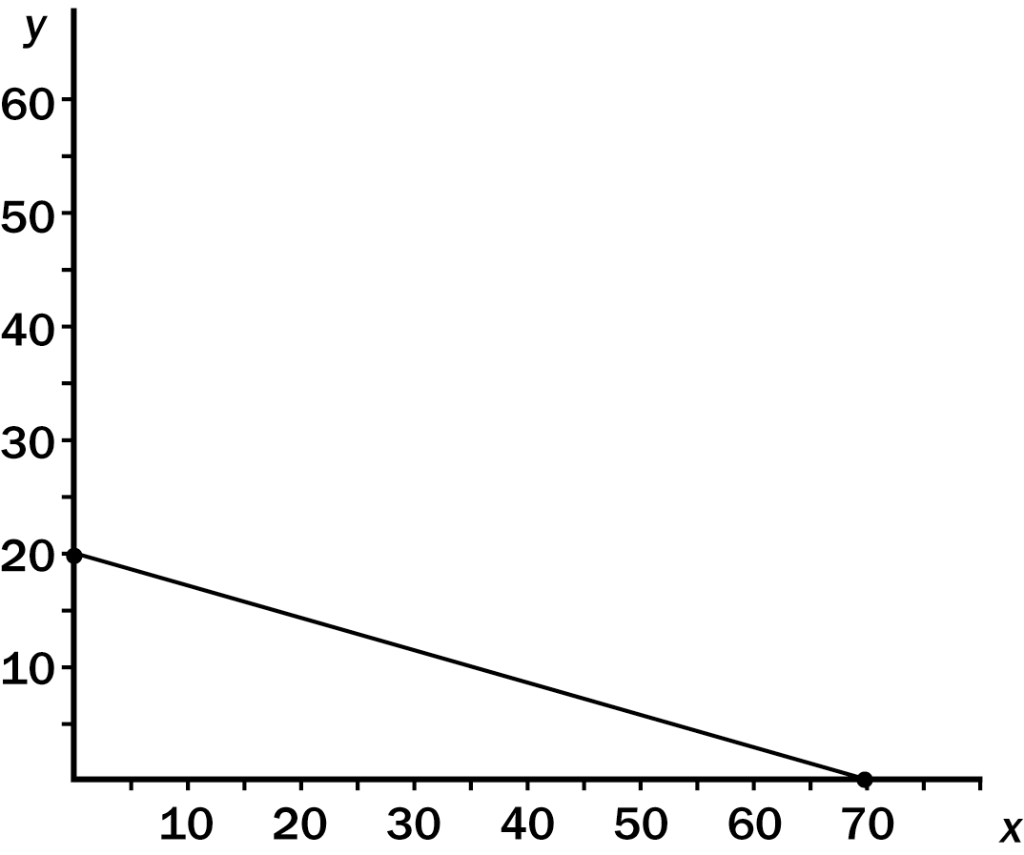
If the price of x is $10, what is the price of y?
a. $15
b. $25
c. $35
d. $70
ANS: C PTS: 1 DIF: 3 REF: 21-1
TOP: Budget constraint MSC: Analytical
29. Budget constraints exist for consumers because
a. their utility from consuming goods eventually reaches a maximum level.
b. even with unlimited incomes they have to pay for each good they consume.
c. they have to pay for goods and they have limited incomes.
d. prices and incomes are inversely related.
ANS: C PTS: 1 DIF: 2 REF: 21-1
TOP: Budget constraint MSC: Interpretive
30. A family on a trip budgets $800 for meals and gasoline. If the price of a meal for the family is $50, how many meals can the family buy if they do not buy any gasoline?
a. 8
b. 16
c. 24
d. 32
ANS: B PTS: 1 DIF: 2 REF: 21-1
TOP: Budget constraint MSC: Applicative
31. A family on a trip budgets $800 for meals and hotel accommodations. Suppose the price of a meal is $40. In addition, suppose the family could afford a total of 8 nights in a hotel if they don’t buy any meals. How many meals could the family afford if they gave up two nights in the hotel?
a. 1
b. 2
c. 5
d. 8
ANS: C PTS: 1 DIF: 3 REF: 21-1
TOP: Budget constraint MSC: Applicative
32. If the price of bread is zero, the budget constraint between bread (on the vertical axis) and cheese (on the horizontal axis) would
a. be vertical.
b. coincide with the vertical axis.
c. coincide with the horizontal axis.
d. be horizontal.
ANS: A PTS: 1 DIF: 2 REF: 21-1
TOP: Budget constraint MSC: Analytical
Scenario 21-1
Suppose the price of pizza is $10, the price of cola is $1, and the consumer’s income is $50. In addition, suppose the consumer’s budget constraint measures pizza on the horizontal axis and cola on the vertical axis.
33. Refer to Scenario 21-1. If the price of cola doubles to $2, then the
a. budget constraint intersects the vertical axis at 25 colas.
b. slope of the budget constraint rises to -2.
c. budget constraint intersects the vertical axis at 100 colas.
d. budget constraint shifts inward in a parallel fashion.
ANS: A PTS: 1 DIF: 2 REF: 21-1
TOP: Budget constraint MSC: Applicative
34. Refer to Scenario 21-1. If the consumer’s income rises to $60, then the budget line for pizza and cola would
a. now intersect the horizontal axis at 6 pizzas and the vertical axis at 60 colas.
b. not change.
c. now intersect the horizontal axis at 4 pizzas and the vertical axis at 16 colas.
d. rotate outward along the cola axis.
ANS: A PTS: 1 DIF: 1 REF: 21-1
TOP: Budget constraint MSC: Applicative
35. An increase in a consumer’s income
a. increases the slope of the consumer’s budget constraint.
b. has no effect on the slope of the consumer’s budget constraint.
c. decreases the slope of the consumer’s budget constraint.
d. has no effect on the consumer’s budget constraint.
ANS: B PTS: 1 DIF: 2 REF: 21-1
TOP: Budget constraint MSC: Analytical
36. A decrease in a consumer’s income
a. increases the slope of the consumer’s budget constraint.
b. has no effect on the consumer’s budget constraint.
c. decreases the slope of the consumer’s budget constraint.
d. has no effect on the slope of the consumer’s budget constraint.
ANS: D PTS: 1 DIF: 2 REF: 21-1
TOP: Budget constraint MSC: Analytical
37. The price of gin has risen from $7 to $9 per bottle, the price of cocktail onions has fallen from $6 to $5 per jar, and Elizabeth’s income has stayed fixed at $46 per week. Since the price changes, Elizabeth has been buying 4 bottles of gin and 2 jars of cocktail onions per week. At the original prices, 4 bottles of gin and 2 jars of cocktail onions would have
a. exactly exhausted her income.
b. cost more than her income.
c. cost less than her income.
d. could have maximized her satisfaction given her budget constraint.
ANS: C PTS: 1 DIF: 2 REF: 21-1
TOP: Budget constraint MSC: Applicative
38. The price of gin has risen from $7 to $9 per bottle, the price of cocktail onions has fallen from $6 to $5 per jar, and Elizabeth’s income has stayed fixed at $46 per week. If you put gin on the vertical axis and cocktail onions on the horizontal axis, then the budget constraint
a. is steeper after the price changes.
b. is flatter after the price changes.
c. is the same after the price changes.
d. shifts in parallel to the old budget constraint after the price changes.
ANS: B PTS: 1 DIF: 2 REF: 21-1
TOP: Budget constraint MSC: Applicative
39. Suppose the only two goods that Brett consumes are wine and cheese. When wine sells for $10 a bottle and cheese sell for $10 a pound, he buys 6 bottles of wine and 4 pounds of cheese — spending his entire income of $100. One day the price of wine falls to $5 a bottle and the price of cheese increases to $20 a pound, while his income does not change. The bundle of wine and cheese that he purchased at the old prices, now costs, at the new prices,
a. the same amount.
b. less than Brett’s income.
c. more than Brett’s income.
d. not enough information to answer the question.
ANS: C PTS: 1 DIF: 1 REF: 21-1
TOP: Budget constraint MSC: Applicative
40. Suppose the only two goods that Brett consumes are wine and cheese. When wine sells for $10 a bottle and cheese sell for $10 a pound, he buys 6 bottles of wine and 4 pounds of cheese — spending his entire income of $100. One day the price of wine falls to $5 a bottle and the price of cheese increases to $20 a pound, while his income does not change. If you place wine on the vertical axis and cheese on the horizontal axis, then
a. the slope of Brett’s budget has not changed.
b. the slope of Brett’s budget constraint is flatter at the new prices.
c. the slope of Brett’s budget constraint is steeper at the new prices.
d. Brett’s budget constraint has shifted in parallel to the budget constraint with the old prices.
ANS: C PTS: 1 DIF: 2 REF: 21-1
TOP: Budget constraint MSC: Applicative
41. Consider the indifference curve map for nickels and quarters. Assume nickels are on the vertical axis and quarters are on the horizontal axis. The indifference curves for nickels and quarters
a. are straight lines with slope of -1/5
b. are straight lines with a slope of -1.
c. are straight lines with a slope of -5.
d. are L shaped.
ANS: C PTS: 1 DIF: 2 REF: 21-2
TOP: Perfect substitutes MSC: Applicative
42. All of the following are properties of indifference curves except
a. higher indifference curves are preferred to lower ones.
b. indifference curves are downward sloping.
c. indifference curves do not cross.
d. indifference curves are bowed outward.
ANS: D PTS: 1 DIF: 1 REF: 21-2
TOP: Indifference Curve MSC: Interpretive
43. A consumer’s preferences for right shoes and left shoes can be represented by indifference curves that are
a. bowed out from the origin
b. bowed in towards the origin
c. straight lines
d. right angles
ANS: D PTS: 1 DIF: 1 REF: 21-2
TOP: Indifference Curve MSC: Interpretive
44. A consumer’s preferences for $1 bills and $20 bills can be represented by indifference curves that are
a. bowed out from the origin
b. bowed in towards the origin
c. straight lines
d. right angles
ANS: C PTS: 1 DIF: 1 REF: 21-2
TOP: Indifference Curve MSC: Interpretive
45. Economists represent a consumer’s preferences using
a. demand curves.
b. budget constraints.
c. indifference curves.
d. supply curves.
ANS: C PTS: 1 DIF: 1 REF: 21-2
TOP: Indifference Curve MSC: Definitional
46. If two bundles of goods give a consumer the same satisfaction, the consumer must be
a. on her budget constraint.
b. in a position of equilibrium.
c. indifferent between the bundles.
d. Both a and c are correct.
ANS: C PTS: 1 DIF: 2 REF: 21-2
TOP: Indifference Curve MSC: Interpretive
Figure 21-4
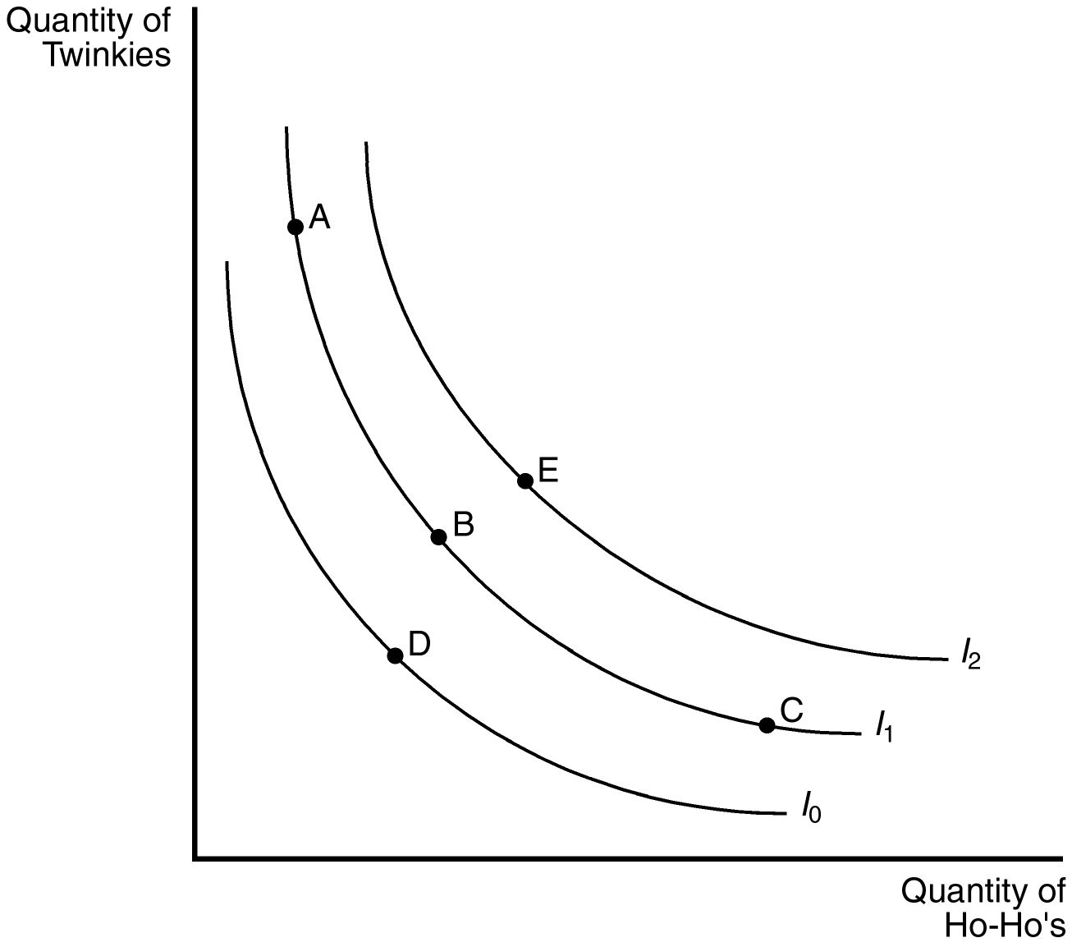
47. Refer to Figure 21-4. Which of the following statements is correct?
a. Point A is preferred equally to point E.
b. Point A is preferred equally to point C.
c. The bundle associated with point B contains more Ho-Ho’s than that associated with point C.
d. The bundles along indifference curve I₁ are preferred to those along indifference curve I₂.
ANS: B PTS: 1 DIF: 1 REF: 21-2
TOP: Indifference Curve MSC: Analytical
48. Refer to Figure 21-4. Which of the following statements is true?
a. If a consumer moves from point C to point A, her loss of Ho-Ho’s cannot be compensated for by an increase in Twinkies.
b. Point E is preferred to all other points identified in the figure.
c. Since more is preferred to less, point C may be preferred to point E in some circumstances for this consumer.
d. Even though point E has more of both goods than point B, we could draw a different set of indifference curves in which point B is preferred to point E.
ANS: B PTS: 1 DIF: 2 REF: 21-2
TOP: Indifference Curve MSC: Analytical
49. Refer to Figure 21-4. Which of the following statements is not true for a consumer who moves from point B to point C?
a. At point C the consumer would be willing to give up a larger number of Ho-Hos in exchange for a Twinkie than at point B.
b. The marginal rate of substitution at points C and B are the same since the points lie on the same indifference curve.
c. The consumer is willing to sacrifice Twinkies to obtain Ho-Ho’s.
d. The consumer receives the same level of satisfaction at points B and C.
ANS: B PTS: 1 DIF: 2 REF: 21-2
TOP: Indifference Curve MSC: Analytical
50. Refer to Figure 21-4. Which of the following statements is true for a consumer who moves from point A to point D?
a. It is difficult to compare the level of consumer satisfaction between points D and A.
b. The consumer is indifferent between point A and point D.
c. The consumer is definitely worse off.
d. The consumer is likely to place a higher relative value on Twinkies at point A than at point D.
ANS: C PTS: 1 DIF: 2 REF: 21-2
TOP: Indifference Curve MSC: Analytical
51. Refer to Figure 21-4. A person that chooses to consume bundle C is likely to
a. receive higher total satisfaction at point C than at point A.
b. spend more on bundle C than bundle A.
c. receive higher marginal utility from Ho-Ho’s than from Twinkies.
d. receive higher marginal utility from Twinkies than from Ho-Ho’s.
ANS: D PTS: 1 DIF: 2 REF: 21-3
TOP: Indifference Curve MSC: Analytical
52. Indifference curves graphically represent
a. an income level sufficient to allow an individual to achieve a given level of satisfaction.
b. the constraints faced by individuals.
c. an individual’s preferences.
d. the relative price of commodities.
ANS: C PTS: 1 DIF: 1 REF: 21-2
TOP: Indifference Curve MSC: Definitional
53. The slope of an indifference curve is
a. the rate of change of consumer’s preferences.
b. the marginal rate of preference.
c. the marginal rate of substitution.
d. always equal to the slope of the budget constraint.
ANS: C PTS: 1 DIF: 1 REF: 21-2
TOP: Marginal rate of substitution MSC: Definitional
54. The rate at which a consumer is willing to exchange one good for another, and maintain a constant level of satisfaction, is called the
a. relative expenditure ratio.
b. value of marginal product.
c. marginal rate of substitution.
d. relative price ratio.
ANS: C PTS: 1 DIF: 1 REF: 21-2
TOP: Marginal rate of substitution MSC: Definitional
55. If an indifference curve is bowed in toward the origin, the marginal rate of substitution is
a. not likely to reflect the relative value of goods.
b. likely to be constant for all bundles along the indifference curve.
c. likely to be identical to the price ratio for each bundle along the indifference curve.
d. different for each bundle along the indifference curve.
ANS: D PTS: 1 DIF: 1 REF: 21-2
TOP: Marginal rate of substitution MSC: Interpretive
56. The marginal rate of substitution is
a. the slope of a budget constraint.
b. always constant.
c. the slope of an indifference curve.
d. the point at which the budget constraint and the indifference curve is tangent.
ANS: C PTS: 1 DIF: 1 REF: 21-2
TOP: Marginal rate of substitution MSC: Definitional
57. The rate at which a consumer is willing to trade one good for another to maintain the same level of satisfaction is affected by
a. the prices of the products.
b. the amount of each good the consumer is currently consuming.
c. the consumer’s income.
d. the marginal value product.
ANS: B PTS: 1 DIF: 2 REF: 21-2
TOP: Marginal rate of substitution MSC: Analytical
58. As long as a consumer remains on the same indifference curve
a. she is indifferent to all points which lie on any other indifference curve.
b. her preferences will not affect the marginal rate of substitution.
c. she is unable to decide which bundle of goods to choose.
d. she is indifferent among the points on that curve.
ANS: D PTS: 1 DIF: 1 REF: 21-2
TOP: Marginal rate of substitution MSC: Interpretive
59. A consumer
a. is equally satisfied with any indifference curve.
b. prefers indifference curves with positive slopes.
c. prefers higher indifference curves to lower indifference curves.
d. is generally unable to place all consumption bundles on an indifference curve.
ANS: C PTS: 1 DIF: 1 REF: 21-2
TOP: Indifference Curve MSC: Interpretive
60. A consumer’s preferences provide a
a. ranking of the set of bundles that happen to fall on indifference curves.
b. relative ranking of bundles that provide more of all goods.
c. framework for evaluating market equilibriums.
d. complete ranking of all possible consumption bundles.
ANS: D PTS: 1 DIF: 1 REF: 21-2
TOP: Indifference Curve MSC: Definitional
61. Which of the following is a property of indifference curves?
a. Indifference curves cross to explain higher preferences.
b. Indifference curves have positive slopes.
c. Indifference curves are downward sloping and always linear.
d. Indifference curves are bowed in toward the origin.
ANS: D PTS: 1 DIF: 1 REF: 21-2
TOP: Indifference Curve MSC: Interpretive
62. Higher indifference curves are preferred to lower ones as long as the
a. marginal rate of substitution is diminishing.
b. products in the bundle are “bads.”
c. products in the bundle are “goods.”
d. budget constraint does not shift.
ANS: C PTS: 1 DIF: 2 REF: 21-2
TOP: Indifference Curve MSC: Interpretive
63. Indifference curves that cross would suggest that
a. the consumer does not prefer more to less.
b. the consumer is likely to prefer a redistribution of income from rich to poor.
c. different individuals have different preferences for the same goods.
d. the marginal rate of substitution is the same for both indifference curves.
ANS: A PTS: 1 DIF: 2 REF: 21-2
TOP: Indifference Curve MSC: Analytical
64. When indifference curves are bowed in toward the origin,
a. a consumer is less inclined to trade away goods they are lacking.
b. a consumer’s willingness to trade away goods they have in abundance diminishes.
c. an increase in income will shift the indifference curve away from the origin.
d. a decrease in income will shift the indifference curve away from the origin.
ANS: A PTS: 1 DIF: 2 REF: 21-2
TOP: Indifference Curve MSC: Analytical
65. Which of the following is not true? Indifference curves
a. are downward sloping.
b. that are closer to the origin are preferable to indifference curves further from the origin.
c. are bowed in toward the origin.
d. do not cross.
ANS: B PTS: 1 DIF: 1 REF: 21-2
TOP: Indifference Curve MSC: Interpretive
66. As one moves down a typical indifference curve, the marginal rate of substitution
a. increases.
b. decreases.
c. is constant.
d. will switch from positive to negative.
ANS: B PTS: 1 DIF: 2 REF: 21-2
TOP: Indifference Curve MSC: Interpretive
67. When two goods are perfect substitutes, the marginal rate of substitution
a. is constant along the indifference curve.
b. decreases as the scarcity of one good increases.
c. increases as the scarcity of one good increases.
d. changes to reflect the consumer’s changing preferences for the goods.
ANS: A PTS: 1 DIF: 1 REF: 21-2
TOP: Indifference Curve MSC: Interpretive
Figure 21-5
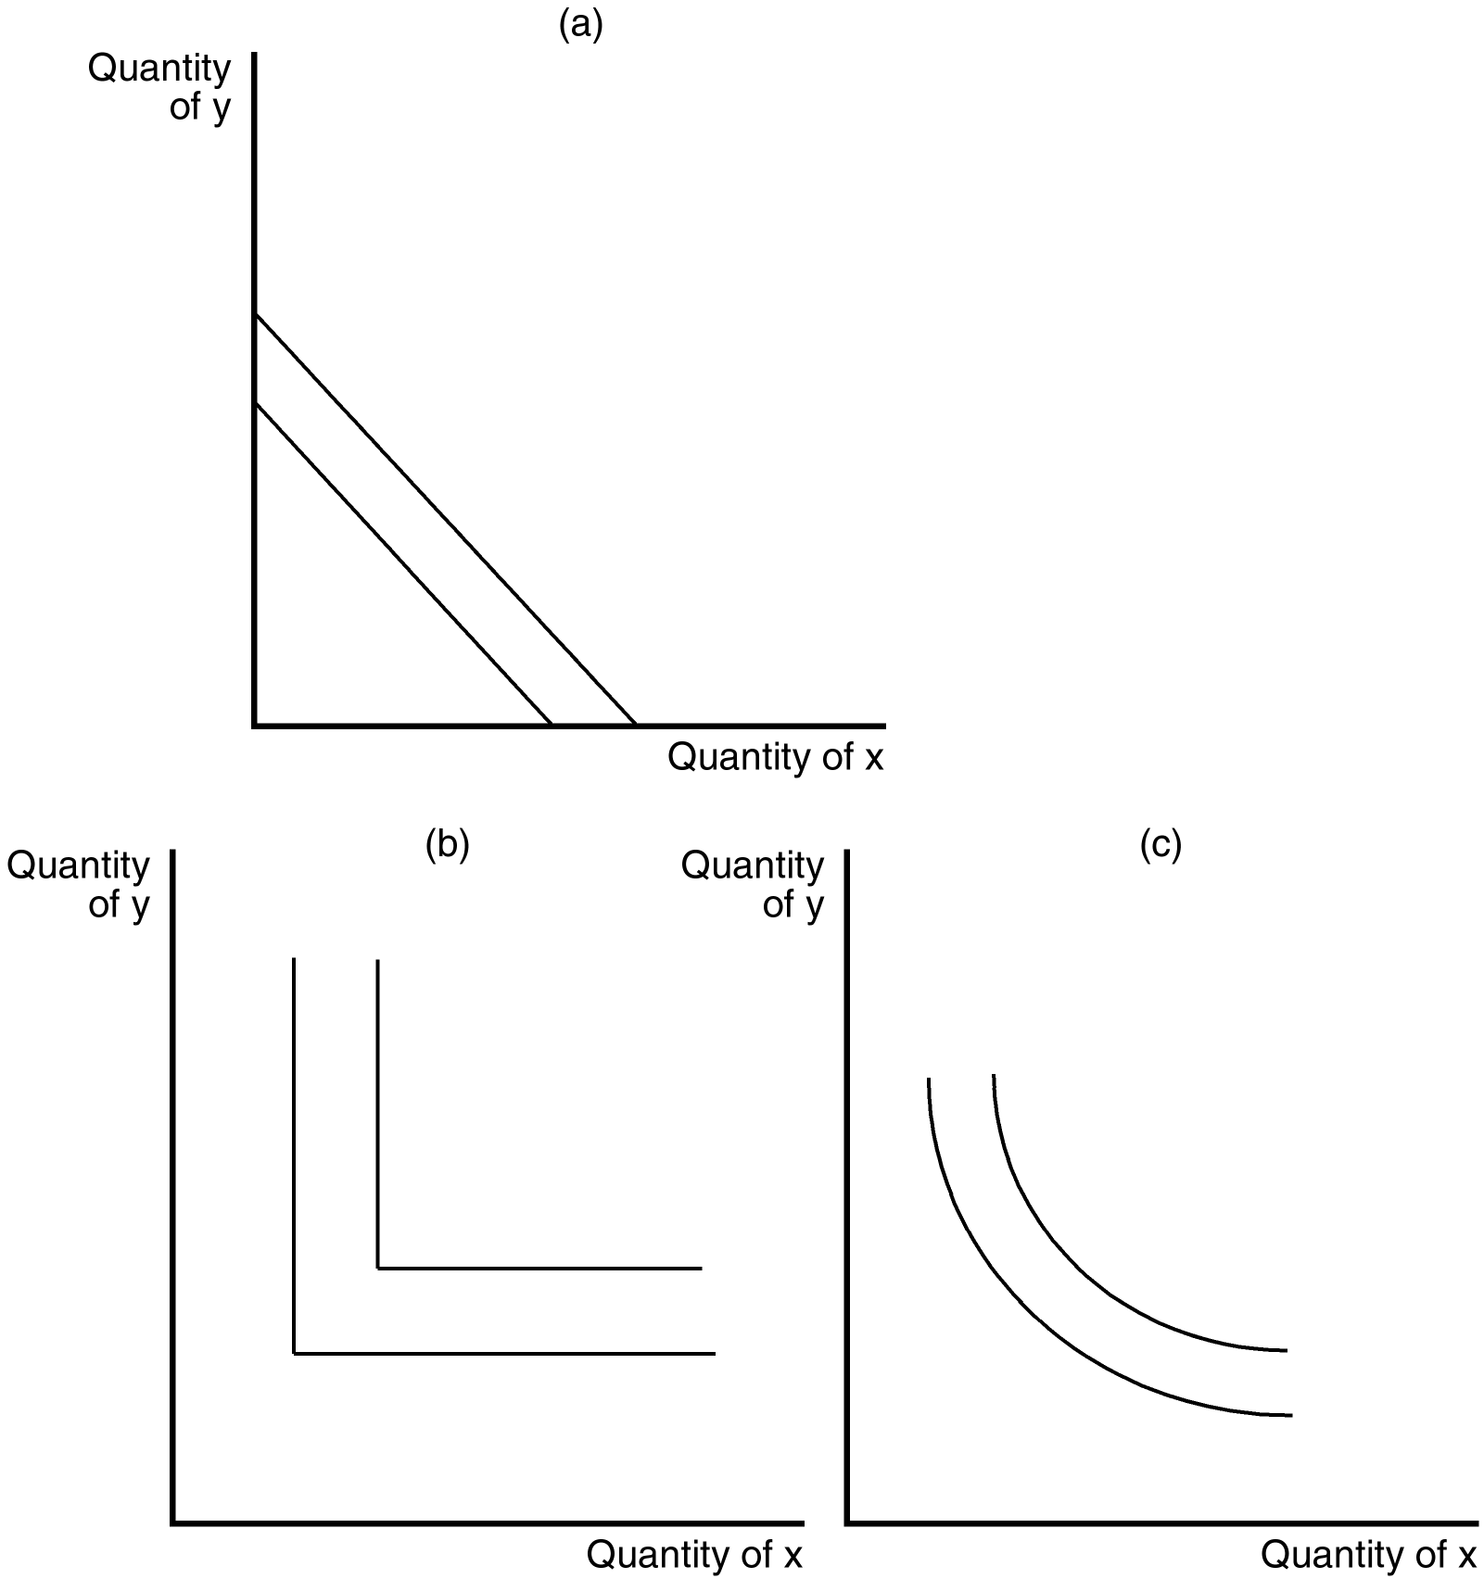
68. Refer to Figure 21-5. Which of the graphs shown may represent indifference curves?
a. graph (a)
b. graph (b)
c. graph (c)
d. All of the above are correct.
ANS: D PTS: 1 DIF: 2 REF: 21-2
TOP: Indifference Curve MSC: Analytical
69. Refer to Figure 21-5. Which of the graphs shown represent indifference curves for perfect substitutes?
a. graph (a)
b. graph (b)
c. graph (c)
d. None of the above is correct.
ANS: A PTS: 1 DIF: 1 REF: 21-2
TOP: Indifference Curve MSC: Interpretive
70. When two goods are perfect complements they will have
a. indifference curves with a positive slope.
b. indifference curves that are right angles.
c. indifference curves with a constant marginal rate of substitution.
d. Both b and c are correct.
ANS: B PTS: 1 DIF: 2 REF: 21-2
TOP: Indifference Curve MSC: Interpretive
71. “Left” gloves and “right” gloves provide a good example of
a. perfect substitutes.
b. perfect complements.
c. negatively sloped indifference curves.
d. positively sloped indifference curves.
ANS: B PTS: 1 DIF: 2 REF: 21-2
TOP: Perfect complements MSC: Analytical
72. When two goods are perfect complements, the indifference curves are
a. positively sloped.
b. negatively sloped.
c. straight lines.
d. right angles.
ANS: D PTS: 1 DIF: 1 REF: 21-2
TOP: Perfect complements MSC: Interpretive
73. A set of indifference curves that are only slightly bowed inward represent goods that could best be described as
a. perfect substitutes.
b. perfect complements.
c. very close substitutes.
d. very close complements.
ANS: C PTS: 1 DIF: 2 REF: 21-2
TOP: Indifference Curve MSC: Analytical
74. The bowed shape of the indifference curve reflects the consumer’s
a. unwillingness to give up a good that he already has in large quantity.
b. unwillingness to purchase a good that he already has in large quantity.
c. greater willingness to give up a good that he already has in large quantity.
d. greater willingness to purchase a good that he already has in large quantity.
ANS: C PTS: 1 DIF: 2 REF: 21-2
TOP: Indifference Curve MSC: Interpretive
75. The following diagram shows one indifference curve representing the preferences for goods x and y for one consumer.
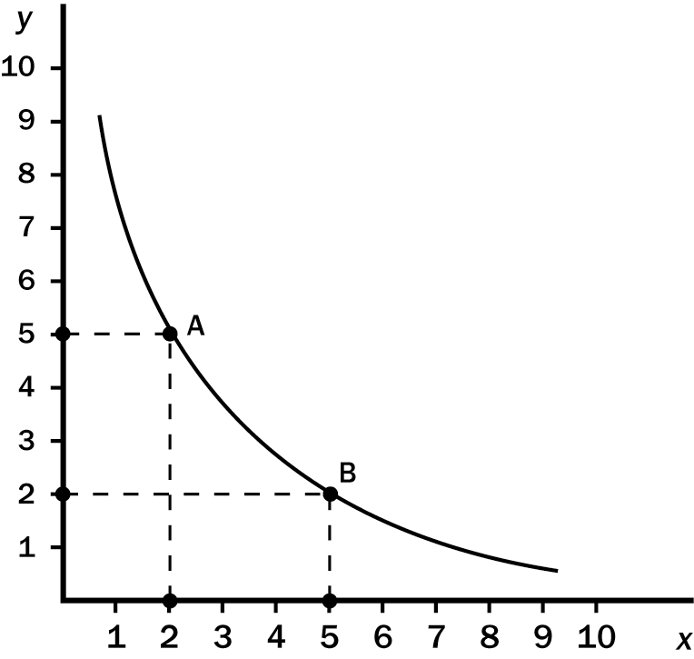
What is the marginal rate of substitution between points A and B?
a. 2/5
b. 1
c. 5/2
d. 3
ANS: B PTS: 1 DIF: 2 REF: 21-2
TOP: Marginal rate of substitution MSC: Analytical
76. The following diagram shows one indifference curve representing the preferences for goods x and y for one consumer.
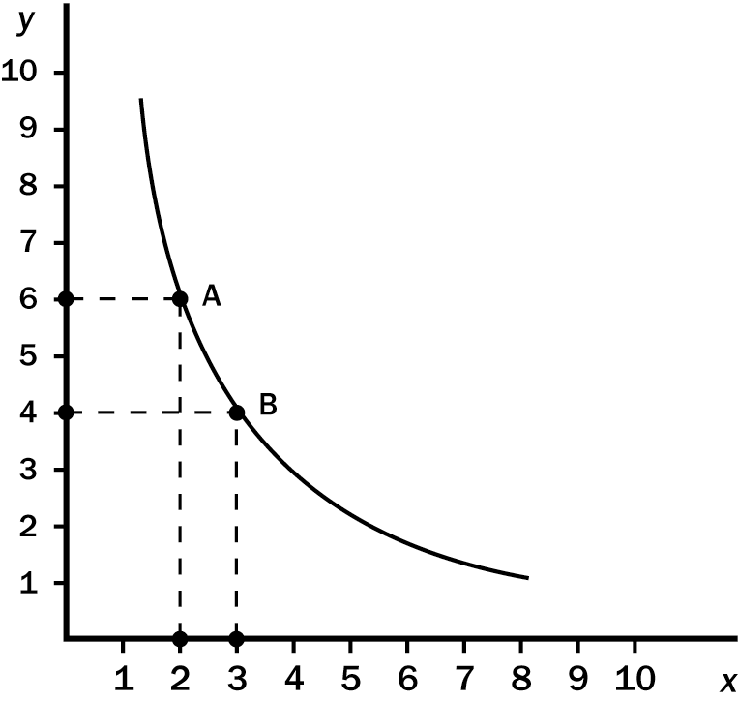
What is the marginal rate of substitution between points A and B?
a. 1/2
b. 4/3
c. 2
d. 3
ANS: C PTS: 1 DIF: 2 REF: 21-2
TOP: Marginal rate of substitution MSC: Analytical
77. A consumer has preferences over two goods: books and movies. Two bundles, which lie on the same indifference curve for this consumer, are shown in the table below.

Bundle | Books | Movies
A | 2 | 3
B | 3 | 2
Which of the following bundles could not lie on the same indifference curve with A and B and satisfy the four properties of indifference curves?
a. One movie and five books
b. Three movies and three books
c. Five movies and one book
d. One movie and seven books
ANS: B PTS: 1 DIF: 2 REF: 21-2
TOP: Indifference Curve MSC: Analytical
78. A consumer has preferences over two goods: books and movies. Three bundles, which all lie on the same indifference curve for this consumer, are shown in the table below.

Bundle | Books | Movies
A | 2 | 4
B | 4 | 2
C | 3 | 3
Assuming that these goods are neither perfect substitutes nor perfect complements for this consumer, which of the following properties of indifference curves would this consumer’s preferences violate?
a. Indifference curves are downward sloping.
b. Indifference curves do not cross.
c. Indifference curves are bowed inward.
d. These bundles do not violate any of the properties of indifference curves.
ANS: C PTS: 1 DIF: 3 REF: 21-2
TOP: Indifference Curve MSC: Analytical
79. A consumer has preferences over two goods: x and y. Three bundles, which all lie on the same indifference curve for this consumer, are shown in the following table.

Bundle | x | y
A | 2 | 8
B | 2 | 2
C | 6 | 2

Which of the following statements regarding these bundles is correct?
a. The goods are perfect substitutes for this consumer.
b. The goods are perfect complements for this consumer.
c. These bundles violate the property that indifference curves are bowed inward.
d. These bundles violate the property that indifference curves do not cross.
ANS: B PTS: 1 DIF: 2 REF: 21-2
TOP: Perfect complements MSC: Analytical
80. As more units of an item are purchased, everything else equal, marginal satisfaction from consuming additional units will tend to
a. decrease at the same rate for all consumers.
b. decrease but at different rates for different people.
c. increase at the same rate for all consumers.
d. increase but at a decreasing rate for all consumers.
ANS: B PTS: 1 DIF: 2 REF: 21-2
TOP: Marginal utility MSC: Interpretive
81. Suppose Rich always uses two packets of sugar with his coffee. Rich’s indifference curves for sugar and coffee are
a. bowed inward.
b. bowed outward.
c. straight lines.
d. L shaped.
ANS: D PTS: 1 DIF: 1 REF: 21-2
TOP: Perfect complements MSC: Applicative
82. Indifference curves tend to be bowed inward because of diminishing
a. marginal rates of substitution.
b. demand for the good as prices rise.
c. income.
d. Both a and b are correct.
ANS: A PTS: 1 DIF: 2 REF: 21-2
TOP: Indifference Curve MSC: Interpretive
83. Laura consumes only beer and chips. Her indifference curves are all bowed inward. Consider the bundles (2,6), (4,4), and (6,2). If Laura is indifferent between (2,6) and (6,2), then Laura must
a. prefer (4,4) to (6,2).
b. be indifferent between (4,4) and (6,2).
c. prefer (6,2) to (4,4).
d. prefer (2,6) to (4,4).
ANS: A PTS: 1 DIF: 2 REF: 21-2
TOP: Consumer choice MSC: Analytical
84. When considering her budget, the highest indifference curve that a consumer can reach is the
a. one that is tangent to the budget constraint.
b. indifference curve farthest from the origin
c. indifference curve that intersects the budget constraint in at least two places.
d. None of the above is correct; consumer preferences are bounded.
ANS: A PTS: 1 DIF: 1 REF: 21-3
TOP: Consumer choice MSC: Interpretive
85. When economists describe preferences, they often use the concept of
a. markets.
b. income.
c. utility.
d. prices.
ANS: C PTS: 1 DIF: 1 REF: 21-3
TOP: Utility MSC: Interpretive
86. Utility measures
a. the income a consumer receives from consuming a bundle of goods.
b. the satisfaction a consumer receives from consuming a bundle of goods.
c. the satisfaction a consumer places on their budget constraint.
d. All of the above are correct.
ANS: B PTS: 1 DIF: 1 REF: 21-3
TOP: Utility MSC: Definitional
87. A rational consumer is likely to have maximized her
a. preferences.
b. marginal rate of substitution.
c. utility.
d. budget constraint.
ANS: C PTS: 1 DIF: 1 REF: 21-3
TOP: Utility MSC: Interpretive
88. If John’s marginal utility derived from the consumption of another candy bar is 1 and the price of the candy bar is $1.50, then
a. this is the last candy bar John will purchase since the marginal utility is less than the price.
b. the opportunity cost of the candy bar is less than $1.50.
c. if John purchases and consumes the candy bar his total satisfaction will go down since the marginal utility is less than the price.
d. there is not enough information to determine if John will or will not purchase the candy bar.
ANS: D PTS: 1 DIF: 3 REF: 21-3
TOP: Marginal utility MSC: Analytical
89. Each of the following are characteristics of an indifference curve map except
a. moving northeast to a new indifference curve will increase utility.
b. points on the same indifference curve yield equal utility.
c. the axes represent levels of utility for each of the goods.
d. indifference curves cannot cross.
ANS: C PTS: 1 DIF: 2 REF: 21-3
TOP: Indifference Curve MSC: Interpretive
90. The marginal rate of substitution between two goods always equals the
a. marginal utility of one divided by the marginal utility of the other.
b. marginal utility of one times the marginal utility of the other.
c. price of one good divided by the price of the other.
d. Both a and c are correct.
ANS: A PTS: 1 DIF: 2 REF: 21-3
TOP: Marginal rate of substitution MSC: Interpretive
91. Dave consumes two normal goods, X and Y, and is currently at an optimum. If the price of good X falls, we can predict with certainty that
a. Dave will definitely consume more of both goods since his real income has risen.
b. the substitution effect will be positive for good X and negative for good Y.
c. may consume more or less of good X and he will definitely consume less of good Y.
d. the substitution effect will offset the income effect for good X.
ANS: B PTS: 1 DIF: 2 REF: 21-3
TOP: Consumer choice MSC: Analytical
92. The relationship between the marginal utility that Wendy gets from eating hamburgers and the number of hamburgers she eats per month is as follows:

Hamburgers | 1 | 2 | 3 | 4 | 5 | 6
Marginal Utility | 20 | 16 | 12 | 8 | 4 | 0
Wendy receives 3 units of utility from the last dollar spent on each of the other goods she consumes. If hamburgers cost $4 each, how many hamburgers will she consume per month if she maximizes utility?
a. 2
b. 3
c. 4
d. 5
ANS: B PTS: 1 DIF: 3 REF: 21-3
TOP: Consumer choice MSC: Applicative
93. George consumes two goods, milk and cookies. He has maximized his utility given his income. Milk costs $2 per gallon and he consumes it to the point where the marginal utility he receives from drinking a gallon of milk is 6. Cookies cost $4 per bag and the relationship between the marginal utility that George gets from eating a bag of cookies and the number of bags he eats per month is as follows:

Bags of Cookies | 1 | 2 | 3 | 4 | 5 | 6
Marginal Utility | 20 | 16 | 12 | 8 | 4 | 0
How many bags of cookies does George buy each month?
a. 1
b. 2
c. 3
d. 4
ANS: C PTS: 1 DIF: 3 REF: 21-3
TOP: Consumer choice MSC: Applicative
94. A fall in the price of DVD players leads consumers to buy more DVD players. From this information we can conclude that DVD players
a. are normal goods.
b. are inferior goods.
c. are Giffen goods.
d. None of the above is correct.
ANS: D PTS: 1 DIF: 3 REF: 21-3
TOP: Income effect MSC: Interpretive
95. Consider a consumer who purchases two goods, X and Y. If the price of good Y falls, then the substitution effect by itself will
a. cause the consumer to buy more of good Y and less of good X.
b. cause the consumer to buy more of good X and less of good Y.
c. not affect the amount of goods X and Y that the consumer buys.
d. result in an upward-sloping demand for good Y if the substitution effect is positive.
ANS: A PTS: 1 DIF: 2 REF: 21-3
TOP: Substitution effect MSC: Analytical
96. If goods X and Y are perfect complements, then if the price of good Y falls, changes in the amount of goods X and Y purchased are due
a. strictly to the substitution effect.
b. strictly to the income effect.
c. to both the income and substitution effects
d. strictly to the complement effect.
ANS: B PTS: 1 DIF: 3 REF: 21-3
TOP: Perfect complements MSC: Analytical
97. The consumer’s optimal choice is the one in which the marginal utility per dollar spent on good X
a. is equal to the marginal utility per dollar saved on good X.
b. is greater than the marginal utility per dollar spent on good Y.
c. is equal to the marginal utility per dollar spent on good Y.
d. is less than the marginal utility per dollar spent on good Y.
ANS: C PTS: 1 DIF: 1 REF: 21-3
TOP: Consumer choice MSC: Interpretive
98. The goal of the consumer is to
a. maximize utility.
b. be on the highest indifference curve.
c. maximize satisfaction.
d. All of the above are the goals of the consumer.
ANS: D PTS: 1 DIF: 1 REF: 21-3
TOP: Consumer choice MSC: Interpretive
99. Beer and pretzels are normal goods. When the price of beer falls, the income effect causes a
a. shift to a lower indifference curve and the consumer buys less pretzels.
b. shift to a higher indifference curve and the consumer buys more pretzels.
c. movement along the indifference curve and the consumer buys less pretzels.
d. movement along the indifference curve and the consumer buys more pretzels.
ANS: B PTS: 1 DIF: 3 REF: 21-3
TOP: Income effect MSC: Analytical
100. Pepsi and pizza are normal goods. When the price of pizza falls, the substitution effect causes a
a. shift to a lower indifference curve and the consumer buys less Pepsi.
b. shift to a higher indifference curve and the consumer buys more Pepsi.
c. movement along the indifference curve and the consumer buys more Pepsi.
d. movement along the indifference curve and the consumer buys less Pepsi.
ANS: D PTS: 1 DIF: 3 REF: 21-3
TOP: Substitution effect MSC: Analytical
101. Beer and pretzels are normal goods. When the price of beer falls, the income effect causes
a. the consumer to feel richer, so the consumer buys more pretzels.
b. the consumer to feel richer, so the consumer buys less pretzels.
c. pretzels to be relatively more expensive, so the consumer buys more pretzels.
d. pretzels to be relatively less expensive, so the consumer buys less pretzels.
ANS: A PTS: 1 DIF: 2 REF: 21-3
TOP: Income effect MSC: Analytical
102. Beer and pretzels are normal goods. When the price of beer falls, the substitution effect causes
a. the consumer to feel richer, so the consumer buys more pretzels.
b. the consumer to feel richer, so the consumer buys less pretzels.
c. pretzels to be relatively more expensive, so the consumer buys less pretzels.
d. pretzels to be relatively less expensive, so the consumer buys more pretzels.
ANS: C PTS: 1 DIF: 2 REF: 21-3
TOP: Substitution effect MSC: Analytical
103. Pepsi and pizza are normal goods. When the price of pizza rises, the substitution effect causes Pepsi to be relatively
a. more expensive, so the consumer buys more Pepsi.
b. more expensive, so the consumer buys less Pepsi.
c. less expensive, so the consumer buys more Pepsi.
d. less expensive, so the consumer buys less Pepsi.
ANS: C PTS: 1 DIF: 2 REF: 21-3
TOP: Substitution effect MSC: Analytical
104. An increase in income will cause a shift in the budget constraint
a. outward.
b. towards the good most consumed.
c. towards the good least consumed.
d. inward.
ANS: A PTS: 1 DIF: 1 REF: 21-3
TOP: Budget constraint MSC: Interpretive
105. A decrease in income will cause a shift in the budget constraint
a. outward.
b. towards the good most consumed.
c. towards the good least consumed.
d. inward.
ANS: D PTS: 1 DIF: 1 REF: 21-3
TOP: Budget constraint MSC: Interpretive
106. An outward shift of the budget constraint will cause a consumer to buy
a. fewer normal goods and more inferior goods.
b. more normal goods and fewer inferior goods.
c. more normal goods and more inferior goods.
d. fewer normal goods and fewer inferior goods.
ANS: B PTS: 1 DIF: 2 REF: 21-3
TOP: Budget constraint MSC: Interpretive
107. To derive the demand curve for a good the
a. income effect must be greater than the substitution effect.
b. substitution effect must be greater than the income effect.
c. substitution effect must be in the same direction as the income effect.
d. income effect and the substitution effect may work in the same or in opposite directions.
ANS: D PTS: 1 DIF: 2 REF: 21-3
TOP: Demand curve MSC: Interpretive
108. An optimizing consumer will select a consumption bundle in which
a. income is maximized and prices are minimized.
b. utility is maximized and prices are minimized.
c. utility is maximized subject to budget constraints.
d. utility is maximized and indifference curves are linear.
ANS: C PTS: 1 DIF: 2 REF: 21-3
TOP: Consumer choice MSC: Interpretive
109. The consumer’s optimum choice is represented by
a. MU_{x}/MU_{y} = P_{x}/P_{y}
b. MU_{x}/P_{x} = MU_{y}/P_{y}
c. MRS_{xy} = P_{x}/P_{y}
d. All of the above are correct.
ANS: D PTS: 1 DIF: 2 REF: 21-3
TOP: Consumer choice MSC: Interpretive
110. An optimizing consumer will select the consumption bundle in which the
a. ratio of total utilities is equal to the relative price.
b. ratio of income to price equals the marginal rate of substitution.
c. marginal rate of substitution is equal to the relative price of the goods.
d. marginal rate of substitution is equal to marginal utility.
ANS: C PTS: 1 DIF: 2 REF: 21-3
TOP: Consumer choice MSC: Interpretive
111. When the indifference curve is tangent to the budget constraint,
a. a consumer cannot be made better off without increasing her income.
b. the consumer is likely to be at a sub-optimal level of consumption.
c. income is at its optimum for a consumer.
d. indifference curves are likely to intersect.
ANS: A PTS: 1 DIF: 2 REF: 21-3
TOP: Consumer choice MSC: Interpretive
112. At the consumer’s optimum
a. the budget constraint would have a slope of MU_{x}/P_{x}.
b. it is still possible for the consumer to increase his consumption of both goods.
c. the indifference curve would intersect the budget constraint at its center point.
d. the slope of the indifference curve is equal to the slope of the budget constraint.
ANS: D PTS: 1 DIF: 2 REF: 21-3
TOP: Consumer choice MSC: Interpretive
113. When a budget constraint shifts outward
a. it could only have been caused by in increase in income.
b. the consumer is indifferent to goods X and Y.
c. it could only have been caused by an increase in the price of one of the goods.
d. the consumer can reach a higher indifference curve.
ANS: D PTS: 1 DIF: 2 REF: 21-3
TOP: Budget constraint MSC: Interpretive
Figure 21-6
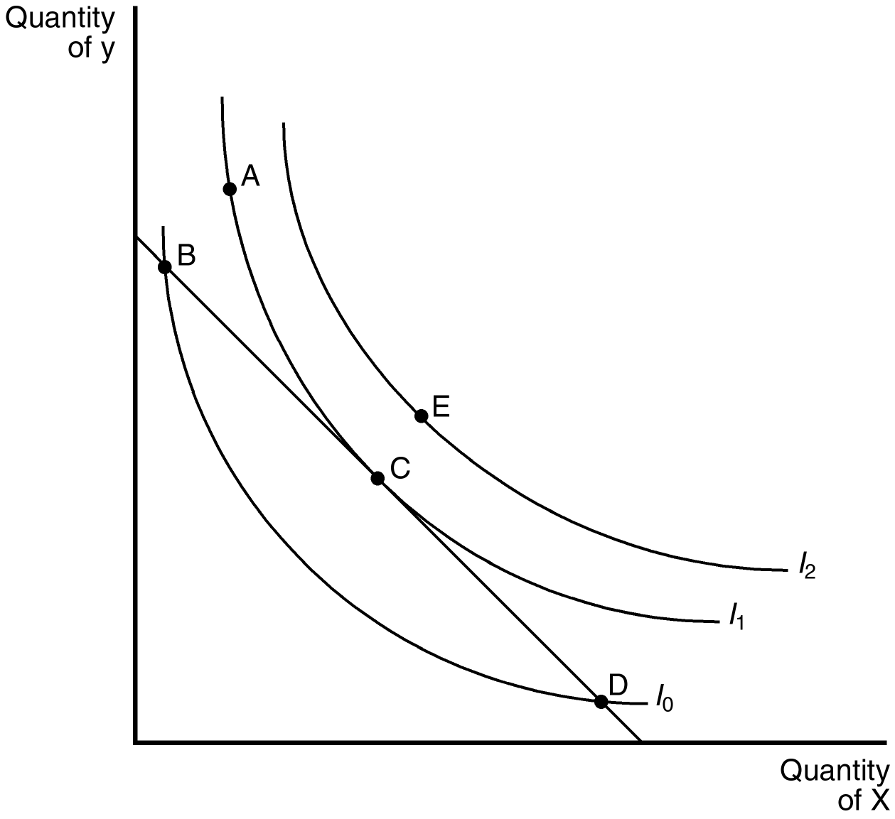
114. Refer to Figure 21-6. The consumer is likely to select the consumption bundle at
a. point B
b. point C
c. point D
d. point E
ANS: B PTS: 1 DIF: 1 REF: 21-3
TOP: Consumer choice MSC: Analytical
115. Refer to Figure 21-6. It would be possible for the consumer to reach I₂ if
a. the price of Y decreases.
b. the price of X decreases.
c. income increases.
d. All of the above would be correct.
ANS: D PTS: 1 DIF: 2 REF: 21-3
TOP: Consumer choice MSC: Analytical
116. Refer to Figure 21-6. Point B represents a point where the
a. MRS_{xy} > P_{y}/P_{x}
b. MRS_{xy} = P_{x}/P_{y}
c. MRS_{xy} < P_{x}/P_{y}
d. MRS_{xy} > P_{x}/P_{y}
ANS: D PTS: 1 DIF: 3 REF: 21-3
TOP: Consumer choice MSC: Analytical
117. Refer to Figure 21-6. Point D represents a point where the
a. MRS_{xy} > P_{y}/P_{x}
b. MRS_{xy} = P_{x}/P_{y}
c. MRS_{xy} < P_{x}/P_{y}
d. MRS_{xy} < P_{y}/P_{x}
ANS: C PTS: 1 DIF: 3 REF: 21-3
TOP: Consumer choice MSC: Analytical
118. A consumer is currently consuming some of good X and some of good Y. If good Y is a normal good for this consumer, a rise in consumer income will definitely cause
a. an increase in the consumption of X.
b. an increase in the consumption of Y.
c. a decrease in the consumption of X.
d. a decrease in the consumption of Y.
ANS: B PTS: 1 DIF: 1 REF: 21-3
TOP: Normal goods MSC: Analytical
119. A normal good is one in which
a. the average consumer chooses to consume at a normal level.
b. the average consumer chooses to consume the good over other similar goods.
c. an increase in income increases consumption of the good.
d. an increase in income decreases consumption of the good.
ANS: C PTS: 1 DIF: 1 REF: 21-3
TOP: Normal goods MSC: Definitional
120. An inferior good is one in which
a. the average consumer chooses not to consume.
b. the good is not equally valued by all consumers.
c. an increase in income increases consumption of the good.
d. an increase in income decreases consumption of the good.
ANS: D PTS: 1 DIF: 1 REF: 21-3
TOP: Normal goods MSC: Definitional
121. Which of the following is most likely an inferior good?
a. an antique car
b. gasoline
c. a bus ticket
d. an airline ticket
ANS: C PTS: 1 DIF: 1 REF: 21-3
TOP: Inferior goods MSC: Applicative
122. If the price of a good increases, all else equal, consumers perceive
a. an increase in purchasing power if the good is an inferior good.
b. an increase in income if the price increase occurs for a normal good.
c. a decrease in purchasing power.
d. a net gain in purchasing power if they decrease consumption of some goods.
ANS: C PTS: 1 DIF: 2 REF: 21-3
TOP: Consumer choice MSC: Analytical
123. When the price of a good increases, all else equal, the higher price
a. reduces the consumer’s set of buying opportunities.
b. leads to a parallel shift of the linear budget constraint.
c. will necessarily lead to an increase in the consumption of goods whose price did not change.
d. generally discourages the consumption of inferior goods.
ANS: A PTS: 1 DIF: 2 REF: 21-3
TOP: Consumer choice MSC: Analytical
124. The consumer’s optimum is where
a. MU_{x}/MU_{y} = P_{y}/P_{x}
b. MU_{x}/P_{y} = MU_{y}/P_{x}
c. P_{x}/MU_{x} = P_{y}/MU_{y}
d. MU_{x}/MU_{y} = P_{x}/P_{y}
ANS: D PTS: 1 DIF: 1 REF: 21-3
TOP: Consumer choice MSC: Definitional
Figure 21-7
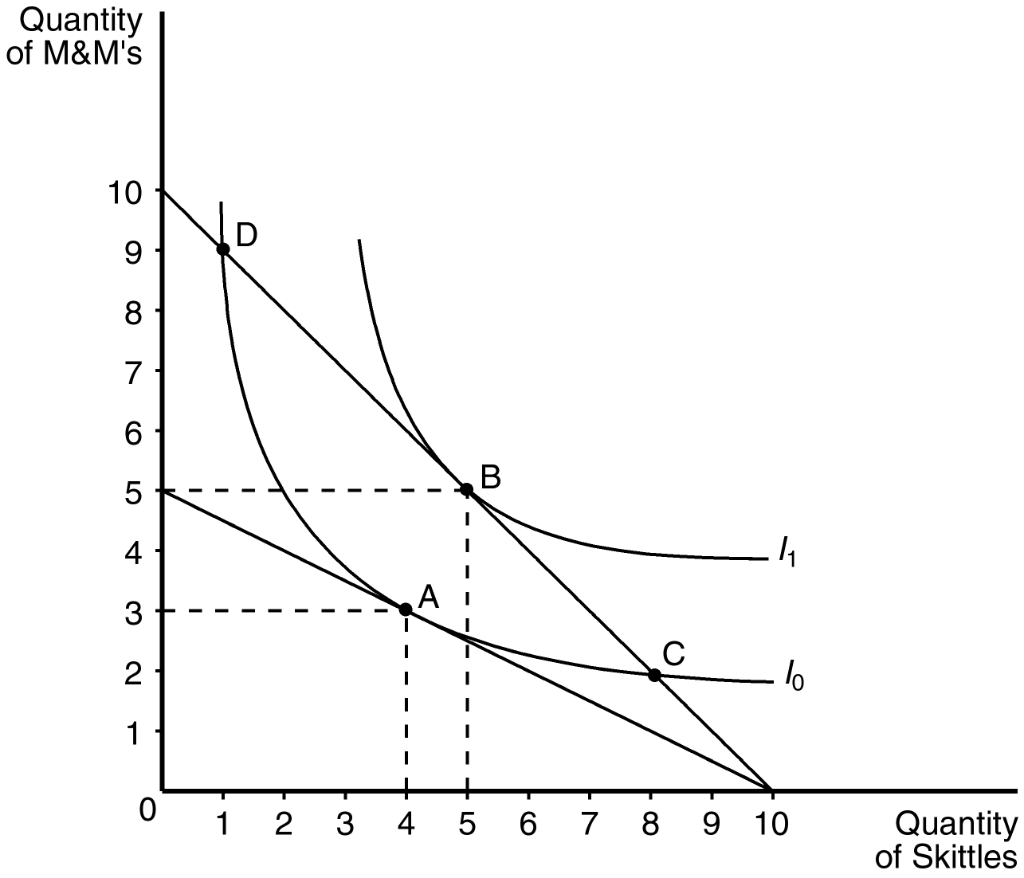
125. Refer to Figure 21-7. Assume that the consumer depicted in the figure has an income of $20. The price of Skittles is $2 and the price of M&M’s is $4. This consumer will choose a consumption bundle where the marginal rate of substitution is
a. 2.
b. 2/3.
c. 1/2.
d. 1/3.
ANS: C PTS: 1 DIF: 2 REF: 21-3
TOP: Consumer choice MSC: Applicative
126. Refer to Figure 21-7. Assume that the consumer depicted in the figure has an income of $20. The price of Skittles is $2 and the price of M&M’s is $2. This consumer will choose to optimize by consuming
a. bundle A.
b. bundle B.
c. bundle C.
d. bundle D.
ANS: B PTS: 1 DIF: 2 REF: 21-3
TOP: Consumer choice MSC: Interpretive
127. Refer to Figure 21-7. Assume that the consumer depicted in the figure faces prices and income such that she optimizes at point B. According to the graph, what change forces the consumer to move to point A?
a. a decrease in the price of Skittles
b. a decrease in the price of M&M’s
c. an increase in the price of Skittles
d. an increase in the price of M&M’s
ANS: D PTS: 1 DIF: 2 REF: 21-3
TOP: Consumer choice MSC: Analytical
128. What are the two effects of a change in a price that a consumer experiences?
a. the income effect and the budget effect
b. the complement effect and the substitute effect
c. the price effect and the preference effect
d. the income effect and the substitution effect
ANS: D PTS: 1 DIF: 2 REF: 21-3
TOP: Income effect | Substitution effect MSC: Definitional
129. Which effect of a price change moves the consumer along the same indifference curve to a point with a new marginal rate of substitution?
a. Budget effect
b. Preference effect
c. Substitution effect
d. Income effect
ANS: C PTS: 1 DIF: 1 REF: 21-3
TOP: Substitution effect MSC: Definitional
130. Assume that a college student purchases only coffee and Snickers. If coffee is an inferior good and Snickers is a normal good, then the income effect associated with an increase in the price of a Snickers will result in
a. a decrease in the consumption of Snickers and a decrease in the consumption of coffee.
b. a decrease in the consumption of Snickers and an increase in the consumption of coffee.
c. an increase in the consumption of Snickers and an increase in the consumption of coffee.
d. an increase in the consumption of Snickers and a decrease in the consumption of coffee.
ANS: B PTS: 1 DIF: 2 REF: 21-3
TOP: Income effect MSC: Analytical
Figure 21-8
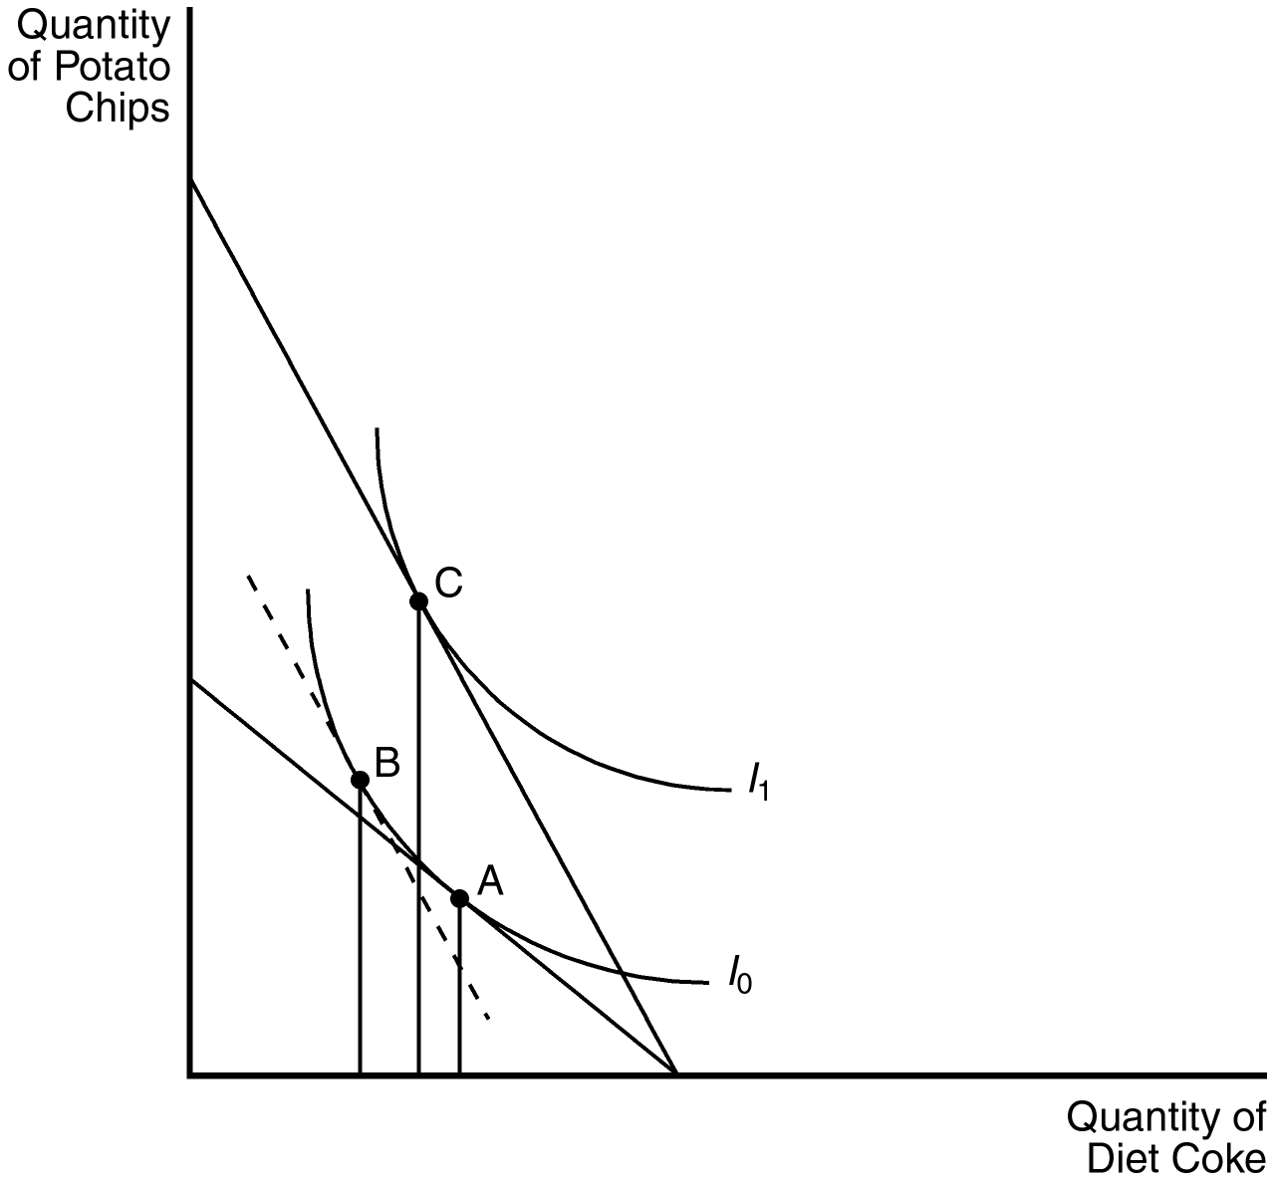
131. Refer to Figure 21-8. If the consumer is currently at point A in the figure, a movement to point B as a result of a decrease in the price of potato chips represents the
a. substitution effect.
b. income effect.
c. budget effect.
d. price effect.
ANS: A PTS: 1 DIF: 2 REF: 21-3
TOP: Giffen Good MSC: Interpretive
132. Refer to Figure 21-8. If the consumer was initially at point A in the figure, a movement from point B to point C as a result of a decrease in the price of potato chips represents the
a. substitution effect.
b. income effect.
c. budget effect.
d. price effect.
ANS: B PTS: 1 DIF: 2 REF: 21-3
TOP: Income effect MSC: Interpretive
133. Refer to Figure 21-8. The shift from point B to point C in the figure is due to the
a. substitution effect of an increase in the price of potato chips.
b. income effect of an increase in the price of potato chips.
c. substitution effect of a decrease in the price of potato chips.
d. income effect of a decrease in the price of potato chips.
ANS: D PTS: 1 DIF: 2 REF: 21-3
TOP: Income effect MSC: Analytical
134. Assume that a college student purchases only coffee and Snickers. The substitution effect associated with a decrease in the price of a Snickers will result in
a. an increase in the consumption of coffee only.
b. a decrease in the consumption of coffee only.
c. an increase in the consumption of Snickers and a decrease in the consumption of coffee.
d. a decrease in the consumption of Snickers and an increase in the consumption of coffee.
ANS: C PTS: 1 DIF: 1 REF: 21-3
TOP: Substitution effect MSC: Analytical
135. Assume that a college student purchases only coffee and Snickers. If both coffee and Snickers are normal goods, then the income effect associated with a decrease in the price of a Snickers will result in
a. a decrease in the consumption of Snickers and an increase in the consumption of coffee.
b. a decrease in the consumption of Snickers and a decrease in the consumption of coffee.
c. an increase in the consumption of Snickers and a decrease in the consumption of coffee.
d. an increase in the consumption of Snickers and an increase in the consumption of coffee.
ANS: D PTS: 1 DIF: 1 REF: 21-3
TOP: Income effect MSC: Analytical
Figure 21-9
136. Refer to Figure 21-9. Assume that the consumer depicted in the figure has an income of $40, the price of a bag of marshmallows is $2, and the price of a bag of chocolate chips is $2. The optimizing consumer will choose to purchase which bundle of marshmallows and chocolate chips?
a. bundle A
b. bundle B
c. bundle C
d. bundle D
ANS: C PTS: 1 DIF: 2 REF: 21-3
TOP: Consumer choice MSC: Applicative
137. Refer to Figure 21-9. Assume that the consumer depicted in the figure has an income of $100 and currently optimizes at point A. When the price of marshmallows decreases to $5, which point will the optimizing consumer choose?
a. Point A
b. Point B
c. Point C
d. Point D
ANS: B PTS: 1 DIF: 2 REF: 21-3
TOP: Consumer choice MSC: Applicative
138. Refer to Figure 21-9. Assume that the consumer depicted in the figure has an income of $40. If the price of chocolate chips is $4.00 and the price of marshmallows is $4.00, the optimizing consumer would choose to purchase
a. 9 marshmallows and 6 chocolate chips.
b. 10 marshmallows and 10 chocolate chips.
c. 5 marshmallows and 5 chocolate chips.
d. 3 marshmallows and 9 chocolate chips.
ANS: C PTS: 1 DIF: 2 REF: 21-3
TOP: Consumer choice MSC: Applicative
139. Refer to Figure 21-9. Assume that the consumer depicted in the figure has an income of $80. If the price of chocolate chips is $4.00 and the price of marshmallows is $4.00, the optimizing consumer would choose to purchase
a. 9 marshmallows and 6 chocolate chips.
b. 10 marshmallows and 10 chocolate chips.
c. 5 marshmallows and 5 chocolate chips.
d. 3 marshmallows and 9 chocolate chips.
ANS: B PTS: 1 DIF: 2 REF: 21-3
TOP: Consumer choice MSC: Applicative
140. Refer to Figure 21-9. Assume that the consumer depicted in the figure has an income of $40. Which of the following price-quantity combinations would be on her demand curve for marshmallows if the price of chocolate chips is $4?
a. $2.00, 3
b. $2.00, 9
c. $4.00, 3
d. $4.00, 9
ANS: B PTS: 1 DIF: 3 REF: 21-3
TOP: Consumer choice MSC: Applicative
141. Refer to Figure 21-9. Assume that the consumer depicted the figure has an income of $50. Which of the following price-quantity combinations would be on her demand curve for marshmallows if the price of chocolate chips is $2.50?
a. $2.50, 6
b. $2.50, 10
c. $5.00, 3
d. $5.00, 5
ANS: B PTS: 1 DIF: 3 REF: 21-3
TOP: Consumer choice MSC: Applicative
142. A way to describe the consumer’s optimum other than “the marginal rate of substitution for two goods is equal to their relative price ratio”, is
a. MU_{x}/MU_{y} = P_{y}/P_{x}.
b. MU_{x}/P_{y} = MU_{y}/P_{x}.
c. MU_{x}/P_{x} = MU_{y}/P_{y}.
d. MU_{y}/MU_{x} = P_{x}/P_{y}.
ANS: C PTS: 1 DIF: 2 REF: 21-3
TOP: Consumer choice MSC: Interpretive
143. A good is an inferior good if the consumer buys less of it when
a. his income rises.
b. the price of the good rises.
c. he feels less well off.
d. his income falls.
ANS: A PTS: 1 DIF: 1 REF: 21-3
TOP: Inferior goods MSC: Interpretive
144. Given a consumer’s indifference map, the demand curve for a good can
a. be derived by moving a consumer’s budget constraint as her income rises.
b. be derived by moving a consumer’s budget constraint as her income rises and she makes choices.
c. be derived by moving a consumer’s budget constraint as the market price changes.
d. not be derived from consumer theory.
ANS: C PTS: 1 DIF: 2 REF: 21-3
TOP: Demand curve MSC: Interpretive
145. The income effect of a price change is depicted by
a. a parallel shift of the budget constraint at the old set of prices.
b. a parallel shift of the budget constraint at the new set of prices.
c. a movement along the budget constraint holding the level of satisfaction constant.
d. not observable and is therefore neither a shift nor a change in the slope of the budget constraint.
ANS: B PTS: 1 DIF: 3 REF: 21-3
TOP: Income effect MSC: Analytical
146. The substitution effect of a price change is depicted by
a. a movement along the budget constraint holding satisfaction constant.
b. a shift in the budget constraint at the old prices.
c. a movement along the consumer’s new indifference curve at the new prices.
d. a movement along the original indifference curve to the point where the marginal rate of substitution equals the price ratio for the new set of prices.
ANS: D PTS: 1 DIF: 3 REF: 21-3
TOP: Substitution effect MSC: Analytical
147. A consumer has preferences over two goods, x and y. Suppose we graph this consumer’s preferences (which satisfy the usual properties of indifference curves) and budget constraint on a diagram with x on the horizontal axis and y on the vertical axis. At the consumer’s current consumption bundle, the consumer is spending all available income, and the marginal rate of substitution is greater than the slope of the budget constraint. We can conclude that
a. the consumer is currently maximizing satisfaction.
b. the consumer could increase satisfaction by consuming more x and less y.
c. the consumer could increase satisfaction by consuming less x and more y.
d. the consumer could purchase more x and more y and increase total satisfaction.
ANS: B PTS: 1 DIF: 3 REF: 21-3
TOP: Consumer choice MSC: Analytical
148. A consumer has preferences over two goods: x and y. Suppose we graph this consumer’s preferences (which satisfy the usual properties of indifference curves) and budget constraint on a diagram with x on the horizontal axis and y on the vertical axis. At the consumer’s current consumption bundle, the consumer is spending all available income, and the marginal rate of substitution is less than the slope of the budget constraint. We can conclude that
a. the consumer is currently maximizing satisfaction.
b. the consumer could increase satisfaction by consuming more x and less y.
c. the consumer could increase satisfaction by consuming less x and more y.
d. the consumer could purchase more x and more y and increase total satisfaction.
ANS: C PTS: 1 DIF: 3 REF: 21-3
TOP: Consumer choice MSC: Analytical
149. Suppose a consumer has preferences over two goods, x and y, which are perfect substitutes. In particular, two units of x is equivalent to one unit of y. If the price of x is $1, the price of y is $3, and the consumer has $30 of income to allocate to these two goods, how much of each good should the consumer purchase to maximize satisfaction?
a. Thirty units of x and zero units of y.
b. Zero units of x and ten units of y.
c. Fifteen units of x and five units of y.
d. Twelve units of x and six units of y.
ANS: A PTS: 1 DIF: 3 REF: 21-3
TOP: Consumer choice MSC: Analytical
150. Good x is an inferior good, but not a Giffen good. When the price of x increases, the consumer will consume
a. more x.
b. the same amount of x.
c. less x.
d. more or less x depending on the size of the income effect relative to the size of the substitution effect.
ANS: C PTS: 1 DIF: 2 REF: 21-3
TOP: Inferior goods MSC: Analytical
151. The following diagram shows two budget lines: A and B.
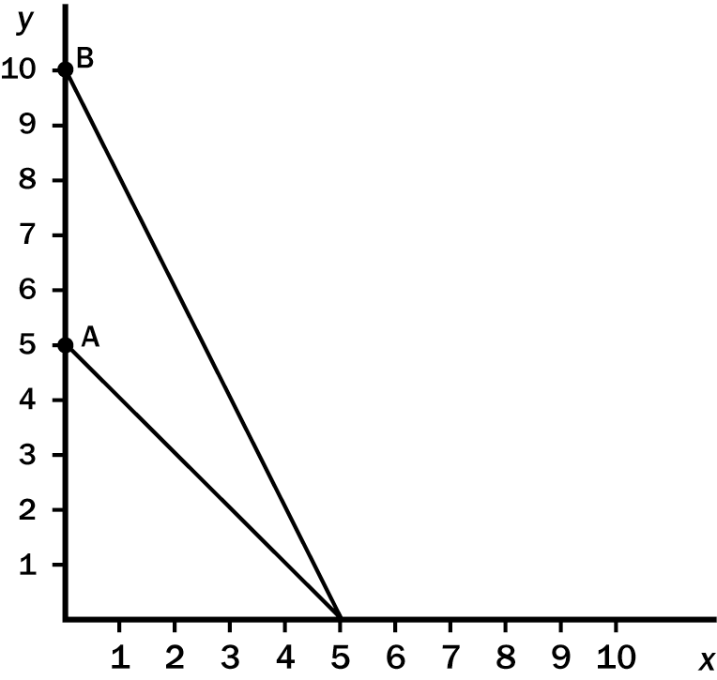
Which of the following could explain the change in the budget line from A to B?
a. A decrease in the price of x.
b. An increase in the price of y.
c. A decrease in the price of y.
d. More than one of the above could explain this change.
ANS: C PTS: 1 DIF: 2 REF: 21-3
TOP: Budget constraint MSC: Analytical
152. The following diagram shows two budget lines: A and B.
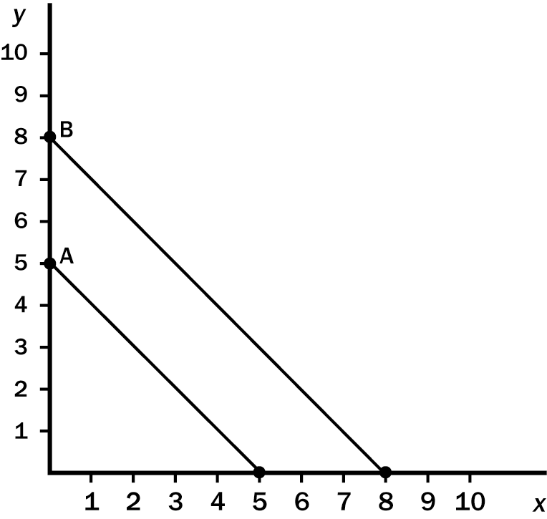
Which of the following could explain the change in the budget line from A to B?
a. A simultaneous decrease in the price of x and the price of y.
b. An increase in income.
c. An increase in income and a decrease in the price of y.
d. Both a and b
ANS: D PTS: 1 DIF: 2 REF: 21-3
TOP: Budget constraint MSC: Analytical
153. The following diagram shows two budget lines: A and B.
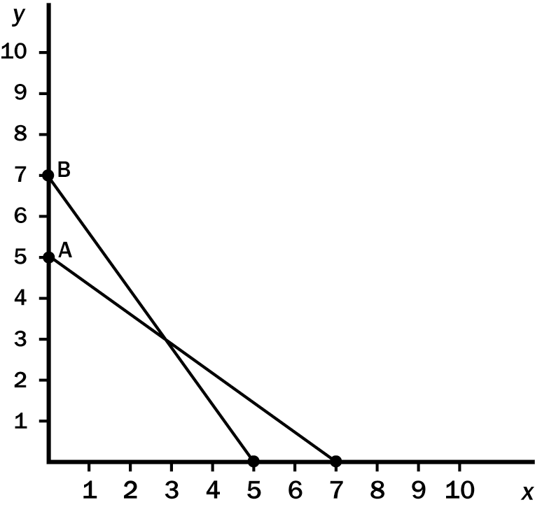
Which of the following could explain the change in the budget line from A to B?
a. A decrease in income and a decrease in the price of x.
b. A decrease in income and an increase in the price of x.
c. An increase in income and a decrease in the price of x.
d. An increase in income and an increase in the price of x.
ANS: D PTS: 1 DIF: 3 REF: 21-3
TOP: Budget constraint MSC: Analytical
154. Which of the following statements best describes the substitution effect?
a. The change in consumption resulting from a change in the consumer’s income holding the prices of the goods constant.
b. The change in consumption resulting from a change in the consumer’s income holding the consumer’s level of satisfaction constant.
c. The change in consumption resulting from a change in the price of one good holding the consumer’s level of satisfaction constant.
d. The change in consumption resulting from a change in the price of one good allowing the consumer’s level of satisfaction to change.
ANS: C PTS: 1 DIF: 2 REF: 21-3
TOP: Substitution effect MSC: Definitional
155. Suppose the price of good x falls and the consumption of good x increases. From this we can infer that
a. x is a normal good.
b. x is an inferior good.
c. x is a Giffen good.
d. None of the above
ANS: D PTS: 1 DIF: 2 REF: 21-3
TOP: Demand curve MSC: Interpretive
156. Suppose the price of good x falls. As a result, the quantity demanded for good x increases for a particular consumer. For this consumer, the substitution effect induced the consumer to purchase more x while the income effect induced the consumer to purchase less x. We can infer that
a. x is a normal good.
b. x is an inferior good.
c. x is a Giffen good.
d. x is a luxury good.
ANS: B PTS: 1 DIF: 3 REF: 21-3
TOP: Inferior goods MSC: Analytical
157. A consumer has preferences over two goods, books and movies. The consumer is currently spending all available income on these two goods and maximizes satisfaction by purchasing ten books and five movies. The price of a movie falls and the consumer optimally chooses to consume eleven books and four movies. From this information we can infer that
a. movies are a normal good for this consumer.
b. movies are an inferior good for this consumer.
c. movies are a Giffen good for this consumer.
d. movies are either an inferior good or a Giffen good for this consumer; we would need information on prices and income to be certain.
ANS: C PTS: 1 DIF: 2 REF: 21-3
TOP: Giffen Good MSC: Analytical
158. Ken consumes two goods, beer and pretzels. A beer costs $1 per bottle and he consumes it to the point where the marginal utility he receives from his last beer is 3. Pretzels cost $2 per bag, and the relationship between the marginal utility he gets from eating a bag of pretzels and the number of bags he eats per month is as follows:

Bags of pretzels | 1 | 2 | 3 | 4 | 5 | 6
Marginal utility | 30 | 20 | 12 | 6 | 2 | 0
If Ken is maximizing his utility, how much does he spend on pretzels each month?
a. $2
b. $6
c. $8
d. $12
ANS: C PTS: 1 DIF: 3 REF: 21-3
TOP: Consumer choice MSC: Applicative
159. Jeffrey spends all of his income on warm-up suits and running shoes, and the price of a warm-up suit is four times the price of a pair of shoes. In order to maximize total utility, Jeffrey should
a. buy four times as many warm-up suits as pairs of running shoes.
b. buy four times as many pairs of running shoes as warm-up suits.
c. buy both items until the marginal utility of a pair of running shoes is four times the marginal utility of a warm-up suit.
d. buy both items until the marginal utility of a warm-up suit is four times the marginal utility of a pair of running shoes.
ANS: D PTS: 1 DIF: 3 REF: 21-3
TOP: Consumer choice MSC: Analytical
160. Jane is maximizing total utility while consuming food and clothing. Her marginal utility from food and clothing are 50 utils and 25 utils, respectively. If clothing is priced at $10 per unit, the price of food must
a. be rising.
b. be falling.
c. equal $5.
d. equal $20.
ANS: D PTS: 1 DIF: 2 REF: 21-3
TOP: Consumer choice MSC: Applicative
161. Higher education is a normal good. If its price falls
a. the quantity demanded of higher education will fall.
b. the substitution and income effects work in opposite directions.
c. the income effect is positive.
d. higher education will be a Giffen good.
ANS: C PTS: 1 DIF: 2 REF: 21-3
TOP: Normal goods MSC: Analytical
162. If the price of hamburgers increases, the substitution effect works to
a. decrease the quantity of hamburgers supplied.
b. increase the number of hamburger buns demanded.
c. decrease the quantity of hamburgers demanded.
d. increase the number of hamburger buns supplied.
ANS: C PTS: 1 DIF: 2 REF: 21-3
TOP: Substitution effect MSC: Analytical
163. If the substitution effect is partly or fully offset by the income effect, we know that the good in question is a(n)
a. complementary good.
b. inferior good.
c. luxury good.
d. normal good.
ANS: B PTS: 1 DIF: 1 REF: 21-3
TOP: Inferior goods MSC: Definitional
164. Suppose that for Edwin, DVDs and trips to the movie theater are perfect substitutes. Currently, Edwin is spending all of his income on trips to the movie theater. If the price of DVDs doubles, the substitution effect will
a. be two times the income effect.
b. be half the income effect.
c. be zero.
d. always increase the number of trips to the movie theater Edwin consumes.
ANS: C PTS: 1 DIF: 3 REF: 21-3
TOP: Substitution effect MSC: Analytical
165. An individual’s demand curve for a good is derived by
a. varying the income level and observing the resulting total utility derived from both goods.
b. varying the price of one good and observing the resulting quantities of the other good.
c. shifting the budget line to the left and calculating the loss in total utility.
d. varying the price of one good and observing the resulting quantities demanded of that good.
ANS: D PTS: 1 DIF: 2 REF: 21-3
TOP: Demand MSC: Interpretive
166. If the consumer’s income and all prices simultaneously double, then
a. the optimum consumption bundle will shift outward relative to the old optimum.
b. the optimum consumption bundle will move leftward along the old budget constraint.
c. the optimum consumption bundle will not change.
d. the optimum consumption bundle will shift inward relative to the old optimum.
ANS: C PTS: 1 DIF: 3 REF: 21-3
TOP: Consumer choice MSC: Applicative
167. If the consumer’s income and all prices simultaneously decrease by one-half, then
a. the optimum will shift outward relative to the old optimum.
b. the optimum will move leftward along the old budget constraint.
c. the optimum will shift inward relative to the old optimum.
d. the optimum will not change.
ANS: D PTS: 1 DIF: 3 REF: 21-3
TOP: Consumer choice MSC: Applicative
168. Suppose at the consumer’s current consumption bundle the marginal rate of substitution of cheese for wine is 1/2 bottle of wine per pound of cheese. The price of one pound of cheese is $6 and the price of a bottle of wine is $10. The consumer should
a. increase consumption of cheese and decrease consumption of wine, and move to a lower indifference curve.
b. increase consumption of cheese and decrease consumption of wine, and move to a higher indifference curve.
c. increase consumption of wine and decrease consumption of cheese, and move to a higher indifference curve.
d. increase consumption of cheese and decrease consumption of wine, and remain on the same indifference curve.
ANS: B PTS: 1 DIF: 3 REF: 21-3
TOP: Consumer choice MSC: Applicative
169. Consider the indifference curve map and budget constraint for two goods (B and K). Suppose the good on the horizontal axis (K) is normal. When the price of the normal good on the horizontal axis (K) increases
a. the substitution effect and income effect both cause an increase in the consumption of K.
b. the substitution effect causes a decrease in the consumption of K and the income effect causes an increase in the consumption of K. However, the substitution effect is greater than the income effect.
c. the substitution effect causes an increase in the consumption of K and the income effect causes a decrease in the consumption of K. However, the substitution effect is greater than the income effect.
d. the substitution effect and income effect both cause a decrease in the consumption of K.
ANS: D PTS: 1 DIF: 2 REF: 21-3
TOP: Normal goods MSC: Analytical
170. The change in consumption that results when a price change moves the consumer along a given indifference curve to a point with a new marginal rate of substitution is called
a. the income effect.
b. the substitution effect.
c. the Giffen good effect.
d. the inferior good effect.
ANS: B PTS: 1 DIF: 1 REF: 21-3
TOP: Substitution effect MSC: Definitional
171. When a consumer experiences a price increase for an inferior good, it is possible that the income effect is
a. greater than the substitution effect and the demand curve will be downward sloping.
b. greater than the substitution effect and the demand curve will be upward sloping.
c. less than the substitution effect and the demand curve will be upward sloping.
d. less than the substitution effect but the substitution effect is positive and the demand curve will be upward sloping.
ANS: B PTS: 1 DIF: 2 REF: 21-4
TOP: Giffen Good MSC: Analytical
172. A Giffen good can be explained as a good for which an increase in the price
a. decreases the quantity supplied.
b. increases the quantity supplied.
c. decreases the quantity demanded.
d. increases the quantity demanded.
ANS: D PTS: 1 DIF: 1 REF: 21-4
TOP: Giffen Good MSC: Definitional
173. Consider the indifference curve map and budget constraint for two goods (B and K). Suppose the good on the horizontal axis (K) is inferior, but not Giffen. When the price of the inferior good on the horizontal axis (K) decreases
a. the substitution effect and income effect both cause an increase in the consumption of K.
b. the substitution effect causes a decrease in the consumption of K and the income effect causes an increase in the consumption of K. However, the substitution effect is greater than the income effect.
c. the substitution effect causes an increase in the consumption of K and the income effect causes a decrease in the consumption of K. However, the substitution effect is greater than the income effect.
d. the substitution effect and income effect both cause a decrease in the consumption of K.
ANS: C PTS: 1 DIF: 2 REF: 21-4
TOP: Inferior goods MSC: Analytical
174. Consider the indifference curve map and budget constraint for two goods (B and K). Suppose the good on the horizontal axis (K) is inferior and Giffen. When the price of the inferior good on the horizontal axis (K) increases
a. the substitution effect causes an increase in the consumption of K and the income effect causes a decrease in the consumption of K. However, the substitution effect is less than the income effect.
b. the substitution effect causes a decrease in the consumption of K and the income effect causes an increase in the consumption of K. However, the substitution effect is greater than the income effect.
c. the substitution effect causes an increase in the consumption of K and the income effect causes a decrease in the consumption of K. However, the substitution effect is greater than the income effect.
d. the substitution effect causes a decrease in the consumption of K and the income effect causes an increase in the consumption of K. However, the substitution effect is less than the income effect.
ANS: D PTS: 1 DIF: 3 REF: 21-4
TOP: Giffen Good MSC: Analytical
175. A Giffen good is one in which the quantity demanded rises as the price rises because the income effect
a. reinforces the substitution effect.
b. reinforces and is greater than the substitution effect.
c. counteracts but is smaller than the substitution effect.
d. counteracts and is greater than the substitution effect.
ANS: D PTS: 1 DIF: 2 REF: 21-4
TOP: Giffen Good MSC: Interpretive
176. Economic theory predicts that an increase in wages
a. will cause a wage earner to work more.
b. will cause a wage earner to work less.
c. will cause a wage earner to be more productive.
d. might cause a wage earner to work more or work less.
ANS: D PTS: 1 DIF: 2 REF: 21-4
TOP: Labor supply MSC: Interpretive
177. The two “goods” used when economists analyze labor supply are
a. work and leisure.
b. work and consumption.
c. saving and consumption.
d. leisure and consumption.
ANS: D PTS: 1 DIF: 1 REF: 21-4
TOP: Labor supply MSC: Interpretive
178. When considering household saving, the relative price between “consuming when young” and “consuming when old” is the
a. consumption rate.
b. interest rate.
c. prime rate.
d. federal funds rate.
ANS: B PTS: 1 DIF: 2 REF: 21-4
TOP: Consumption-saving decision MSC: Interpretive
179. The substitution effect of a wage decrease in the work-leisure model results in the worker choosing to
a. work less than before.
b. work more than before.
c. possibly work more or less than before.
d. work more with a higher level of consumption.
ANS: A PTS: 1 DIF: 3 REF: 21-4
TOP: Labor supply MSC: Analytical
180. In the work-leisure model, suppose consumption and leisure are both normal goods. The income effect of a wage increase results in the worker choosing to
a. work less than before.
b. work more than before.
c. possibly work more or less than before.
d. work more than before with a higher level of consumption.
ANS: A PTS: 1 DIF: 3 REF: 21-4
TOP: Labor supply MSC: Analytical
181. If the interest rate rises, the household could choose to
a. increase consumption when young.
b. increase consumption when old.
c. decrease consumption when young.
d. Any of the above could be correct.
ANS: D PTS: 1 DIF: 2 REF: 21-4
TOP: Consumption-saving decision MSC: Analytical
182. The substitution effect of an increase in the interest rate will result in an increase in
a. consumption when young and increase in savings when young.
b. consumption when old and an increase in savings when young.
c. consumption when young and an increase in savings when old.
d. savings when old and an increase in consumption when old.
ANS: B PTS: 1 DIF: 3 REF: 21-4
TOP: Consumption-saving decision MSC: Analytical
183. The income effect of an increase in the interest rate (when “Consumption when young” and “Consumption when old” are both normal goods) will result in
a. an increase in saving when young.
b. an increase in saving when old.
c. a decrease in saving when young.
d. a decrease in saving when old.
ANS: C PTS: 1 DIF: 2 REF: 21-4
TOP: Consumption-saving decision MSC: Analytical
184. Violations of the law of demand are assumed to occur
a. regularly.
b. only when goods are Giffen goods.
c. only when the substitution effect dominates the income effect.
d. All of the above are correct.
ANS: B PTS: 1 DIF: 2 REF: 21-4
TOP: Giffen Good MSC: Interpretive
Scenario 21-2
Fred has recently graduated from college with a degree in journalism and economics. He has decided to pursue a career as a freelance journalist writing for business newspapers and magazines. Fred is typically awake for 112 hours each week (he sleeps an average of 8 hours each day). For each hour Fred spends writing, he can earn $75.
185. Refer to Scenario 21-2. If Fred decides to spend 80 hours a week playing volleyball on the beach, and the rest of his time writing, how much income will he have available to spend on consumption goods?
a. $900
b. $1,500
c. $2,400
d. $3,000
ANS: C PTS: 1 DIF: 2 REF: 21-4
TOP: Labor supply MSC: Applicative
186. Refer to Scenario 21-2. If Fred’s wage increases to $90 per hour of writing, which of the following points would fall on his budget constraint?
a. 75 hours of leisure, $2,775 of consumption
b. 80 hours of leisure, $2,400 of consumption
c. 85 hours of leisure, $2,430 of consumption
d. 90 hours of leisure, $1,650 of consumption
ANS: C PTS: 1 DIF: 2 REF: 21-4
TOP: Labor supply MSC: Applicative
187. The labor supply curve may have a “backward bending” portion because at higher wages the
a. income effect is smaller than the substitution effect.
b. income effect is larger than the substitution effect.
c. income effect is negative.
d. Any of the above could result in a backward-bending supply curve.
ANS: B PTS: 1 DIF: 2 REF: 21-4
TOP: Labor supply MSC: Interpretive
188. When leisure is a normal good, the income effect from a decrease in wages is evident in
a. a desire to consume more leisure.
b. a desire to consume less leisure.
c. an upward-sloping labor supply curve.
d. a shift in labor demand.
ANS: B PTS: 1 DIF: 3 REF: 21-4
TOP: Labor supply MSC: Analytical
189. The substitution effect from an increase in wages is evident in
a. a decrease in labor demand.
b. a desire to consume less leisure.
c. a desire to consume more leisure.
d. a backward-bending labor supply curve.
ANS: B PTS: 1 DIF: 3 REF: 21-4
TOP: Labor supply MSC: Analytical
Scenario 21-3
Diane knows that she will ultimately face retirement. Assume that Diane will experience two periods in her life, one in which she works and earns income, and one in which she is retired and earns no income. Diane can earn $250,000 during her working period and nothing in her retirement period. She must both save and consume in her work period with an interest rate of 10 percent on savings.
190. Refer to Scenario 21-3. Assume that Diane decides to consume $100,000 in the work period. How much money will she have available for consumption in her retirement period?
a. $100,000
b. $110,000
c. $165,000
d. We can’t determine this from the information provided.
ANS: C PTS: 1 DIF: 2 REF: 21-4
TOP: Consumption-saving decision MSC: Applicative
191. Refer to Scenario 21-3. If the interest rate on savings increases, it is possible that
a. Diane will decrease her savings in the work period.
b. Diane will increase her savings in the work period.
c. Diane will not change her consumption in the work period.
d. All of the above are possible.
ANS: D PTS: 1 DIF: 2 REF: 21-4
TOP: Consumption-saving decision MSC: Analytical
192. Jonathan is planning ahead for retirement and must decide how much to spend and how much to save while he’s working in order to have money to spend when he retires. When the income effect dominates the substitution effect, an increase in the interest rate on savings is likely to
a. decrease saving.
b. increase saving.
c. have no effect on saving.
d. All of the above are correct.
ANS: A PTS: 1 DIF: 3 REF: 21-4
TOP: Consumption-saving decision MSC: Analytical
193. Jonathan is planning ahead for retirement and must decide how much to spend and how much to save while he’s working in order to have money to spend when he retires. When the substitution effect dominates the income effect, an increase in the interest rate on savings is likely to
a. increase saving.
b. decrease saving.
c. have no effect on saving.
d. All of the above are possible.
ANS: A PTS: 1 DIF: 3 REF: 21-4
TOP: Consumption-saving decision MSC: Analytical
194. Giffen goods have positively sloped demand curves because they are
a. inferior goods with no substitution effect.
b. normal goods with no substitution effect.
c. inferior goods for which the substitution effect outweighs the income effect.
d. inferior goods for which the income effect outweighs the substitution effect.
ANS: D PTS: 1 DIF: 2 REF: 21-4
TOP: Giffen Good MSC: Definitional
195. If leisure were an inferior good, then labor supply curves
a. would all be negatively sloped.
b. would all be positively sloped.
c. would all be vertical.
d. could still be positively or negatively sloped.
ANS: B PTS: 1 DIF: 3 REF: 21-4
TOP: Labor supply MSC: Analytical
196. Which of the following statements is false?
a. Reducing taxes on interest income might encourage people to save more.
b. Reducing taxes on interest income might reduce saving.
c. A price increase will create income and substitution effects that will both always work to reduce consumption of the good.
d. Utility is maximized when the marginal rate of substitution between any two goods equals the relative prices of the two goods.
ANS: C PTS: 1 DIF: 3 REF: 21-4
TOP: Giffen Good MSC: Analytical
197. A consumer has preferences over consumption and leisure. When the wage decreases, the consumer chooses to consume less leisure. For this consumer the labor supply curve will
a. slope upward.
b. slope backward.
c. be horizontal.
d. be vertical.
ANS: B PTS: 1 DIF: 3 REF: 21-4
TOP: Labor supply MSC: Analytical
198. John is planning ahead for retirement in a two-period world. When John is young he will earn $1 million, and when John is old and retired he will be given $50,000 from Social Security. If the interest rate between the two time periods is 7 percent, what is the slope of John’s budget constraint when considering the consumption possibilities between the two periods if “consumption when young” is graphed on the horizontal axis?
a. -0.89
b. -1.05
c. -1.07
d. -1.12
ANS: C PTS: 1 DIF: 3 REF: 21-4
TOP: Consumption-saving decision MSC: Analytical
199. Suppose Olivia is planning for retirement in a two-period world. In the first period Olivia is young and earns $1 million, and in the second period Olivia is old and retired and earns nothing. The interest rate is initially 10 percent, but then it falls to 7 percent. Which of the following must be true?
a. After the interest rate falls, the substitution effect will induce Olivia to consume more when she is young.
b. After the interest rate falls, the substitution effect will induce Olivia to consume less when she is young.
c. After the interest rate falls, the income effect will induce Olivia to consume more when she is young.
d. After the interest rate falls, the income effect will induce Olivia to consume less when she is young.
ANS: A PTS: 1 DIF: 3 REF: 21-4
TOP: Consumption-saving decision MSC: Analytical
200. One of the primary research results in tax policy analysis over the last 20 years is that
a. an increase in interest rates will increase saving.
b. an increase in interest rates will decrease saving.
c. lowering taxes on interest income will increase saving.
d. None of the above.
ANS: D PTS: 1 DIF: 2 REF: 21-4
TOP: Consumption-saving decision MSC: Interpretive
201. If a good is a Giffen good, then
a. the supply curve slopes down.
b. the demand curve slopes up.
c. the demand curve is horizontal.
d. there is no optimal level of consumption for the consumer.
ANS: B PTS: 1 DIF: 1 REF: 21-4
TOP: Giffen Good MSC: Definitional
202. Suppose that Annette gets an increase in her wage and she decides to work fewer hours. For her, the substitution effect of the wage change is
a. only partially offset by the income effect.
b. more than offset by the income effect.
c. exactly offset by the income effect.
d. indeterminate since we do not know if consumption and leisure are normal goods for Annette.
ANS: B PTS: 1 DIF: 3 REF: 21-4
TOP: Labor supply MSC: Applicative
203. In the upward-sloping portion of the individual labor supply curve, the substitution effect is
a. greater than the income effect.
b. less than the income effect.
c. equal to the income effect.
d. exactly offset by the income effect.
ANS: A PTS: 1 DIF: 2 REF: 21-4
TOP: Labor supply MSC: Applicative
204. The opportunity cost of current household consumption is the
a. wage rate.
b. market interest rate.
c. price of the goods consumed.
d. explicit cost of consumption.
ANS: B PTS: 1 DIF: 2 REF: 21-4
TOP: Consumption-saving decision MSC: Definitional
205. Suppose that you have $100 today and expect to receive $100 one year from today. Your money market account pays an annual interest rate of 25%, and you may borrow money at that interest rate. If you save all your money, how much money will you have one year from today?
a. $100
b. $125
c. $200
d. $225
ANS: D PTS: 1 DIF: 1 REF: 21-4
TOP: Consumption-saving decision MSC: Applicative
206. Suppose that you have $100 today and expect to receive $100 one year from today. Your money market account pays an annual interest rate of 25%, and you may borrow money at that interest rate. Suppose that you borrow $60 and spend $160 today. After you repay your loan one year from today, how much money will you have available for consumption one year from today?
a. $0
b. $25
c. $50
d. $75
ANS: B PTS: 1 DIF: 3 REF: 21-4
TOP: Consumption-saving decision MSC: Applicative
207. Suppose that you have $100 today and expect to receive $100 one year from today. Your money market account pays an annual interest rate of 25%, and you may borrow money at that interest rate. Consider the budget constraint between “spending today” on the horizontal axis and “spending a year from today” on the vertical axis. What is the slope of this budget constraint?
a. -0.75
b. -1.00
c. -1.25
d. -2.25
ANS: C PTS: 1 DIF: 3 REF: 21-4
TOP: Consumption-saving decision MSC: Applicative
208. Consider the budget constraint between “spending today” on the horizontal axis and “spending a year from today” on the vertical axis. Suppose that you have $100 today and expect to receive $100 one year from today. Your money market account pays an annual interest rate of 25%, and you may borrow money at that interest rate. Suppose now that the interest rate increases to 40%. What happens to the slope of your budget constraint relative to when the interest rate was $25%?
a. it becomes steeper
b. it becomes flatter
c. it doesn’t change because the budget constraint shifts in parallel to the original budget constraint
d. it doesn’t change because the budget constraint shifts out parallel to the original budget constraint
ANS: A PTS: 1 DIF: 3 REF: 21-4
TOP: Consumption-saving decision MSC: Analytical
209. Consider the budget constraint between “spending today” on the horizontal axis and “spending a year from today” on the vertical axis. Suppose that you have $100 today and expect to receive $100 one year from today. Your money market account pays an annual interest rate of 25%, and you may borrow money at that interest rate. Suppose now that the interest rate decreases to 10%. What happens to the slope of your budget constraint relative to when the interest rate was $25%?
a. it becomes steeper
b. it becomes flatter
c. it doesn’t change because the budget constraint shifts in parallel to the original budget constraint
d. it doesn’t change because the budget constraint shifts out parallel to the original budget constraint
ANS: B PTS: 1 DIF: 3 REF: 21-4
TOP: Consumption-saving decision MSC: Analytical
True/False
1. The slope at any point on an indifference curve equals the absolute price at which one consumer is willing to substitute one good for the other.
ANS: F PTS: 1 DIF: 1 REF: 21-2
TOP: Indifference Curve MSC: Interpretive
2. When two goods are strong complements, such as nickels and dimes, the indifference curves are straight lines.
ANS: F PTS: 1 DIF: 1 REF: 21-2
TOP: Perfect Complements MSC: Interpretive
3. When two goods are easily substitutable, such as right and left shoes, the indifference curves are right angles.
ANS: F PTS: 1 DIF: 1 REF: 21-2
TOP: Perfect Substitutes MSC: Interpretive
4. The marginal rate of substitution is the slope of the budget constraint.
ANS: F PTS: 1 DIF: 1 REF: 21-2
TOP: Marginal Rate of Substitution MSC: Definitional
5. The marginal rate of substitution does not change for perfect substitutes.
ANS: T PTS: 1 DIF: 1 REF: 21-2
TOP: Perfect Substitutes MSC: Interpretive
6. At the optimum, the consumer chooses consumption of the two goods so that the marginal rate of substitution equals the relative price ratio.
ANS: T PTS: 1 DIF: 1 REF: 21-3
TOP: Consumer choice MSC: Interpretive
7. If a consumer wants more of a good when his income rises, economists call it an inferior good.
ANS: F PTS: 1 DIF: 1 REF: 21-3
TOP: Normal goods MSC: Definitional
8. If a consumer wants less of a good when her income rises, economists call it an inferior good.
ANS: T PTS: 1 DIF: 1 REF: 21-3
TOP: Inferior goods MSC: Definitional
9. The income effect of a price change is the change in consumption that results from the movement to a different indifference curve.
ANS: T PTS: 1 DIF: 1 REF: 21-3
TOP: Income Effect MSC: Interpretive
10. The substitution effect of a price change is the change in consumption that results from the movement to a different indifference curve.
ANS: F PTS: 1 DIF: 1 REF: 21-3
TOP: Substitution effect MSC: Interpretive
11. Economists use the term Giffen good to describe a good that violates the law of demand.
ANS: T PTS: 1 DIF: 1 REF: 21-4
TOP: Giffen Good MSC: Definitional
12. Giffen goods are inferior goods for which the income effect dominates the substitution effect.
ANS: T PTS: 1 DIF: 1 REF: 21-4
TOP: Giffen Good MSC: Definitional
13. The substitution effect in the work-leisure model induces a person to work less in response to higher wages, which tends to make the labor supply curve slope upward.
ANS: F PTS: 1 DIF: 1 REF: 21-4
TOP: Labor Supply MSC: Interpretive
14. Some economists have advocated reducing the taxation of interest and other capital income, arguing that such a policy change would raise the after-tax interest rate that savers can earn and would thereby encourage people to save more.
ANS: T PTS: 1 DIF: 1 REF: 21-4
TOP: Consumption-saving decision MSC: Interpretive
15. A rise in the interest rate will generally result in people consuming more when they are old.
ANS: T PTS: 1 DIF: 1 REF: 21-4
TOP: Consumption-saving decision MSC: Interpretive
Short Answer
1. Answer the following questions based on the table. A consumer is able to consume the following bundles of rice and beans when the price of rice is $2 and the price of beans is $3.

RICE | BEANS
12 | 0
6 | 4
0 | 8

a. How much is this consumer’s income?
b. Draw a budget constraint given this information. Label it B.
c. Construct a new budget constraint showing the change if the price of rice falls $1. Label this C.
d. Given the original prices for rice ($2) and beans ($3), construct a new budget constraint if this consumer’s income increased to $48. Label this D.
ANS:
a. $24
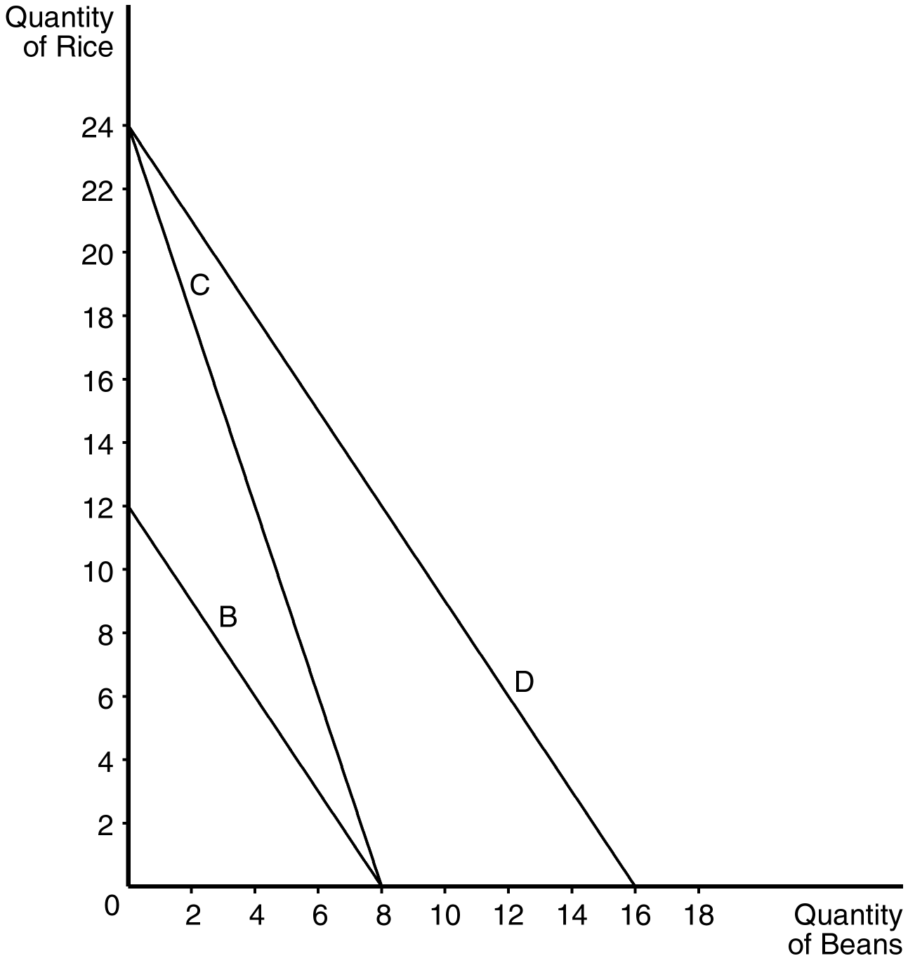
b.
c.
d.

PTS: 1 DIF: 3 REF: 21-1
TOP: Budget constraint MSC: Applicative
2. Draw a budget constraint that is consistent with the following prices and income.
Income = 200
P_{Y} = 50
P_{X} = 25
a. Demonstrate how your original budget constraint would change if income increases to 500.
b. Demonstrate how your original budget constraint would change if P_{Y} decreases to 20.
c. Demonstrate how your original budget constraint would change if P_{X} increases to 40.
ANS:
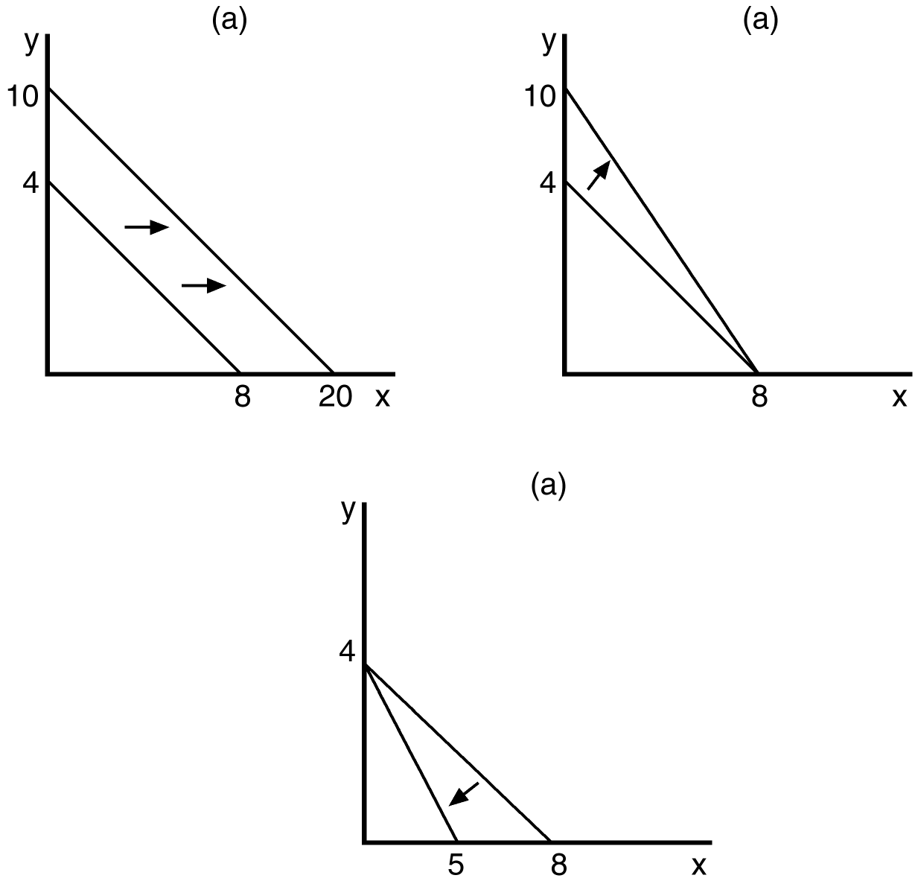
PTS: 1 DIF: 2 REF: 21-1
TOP: Budget constraint MSC: Applicative
3. Assume that a consumer faces the following budget constraints.
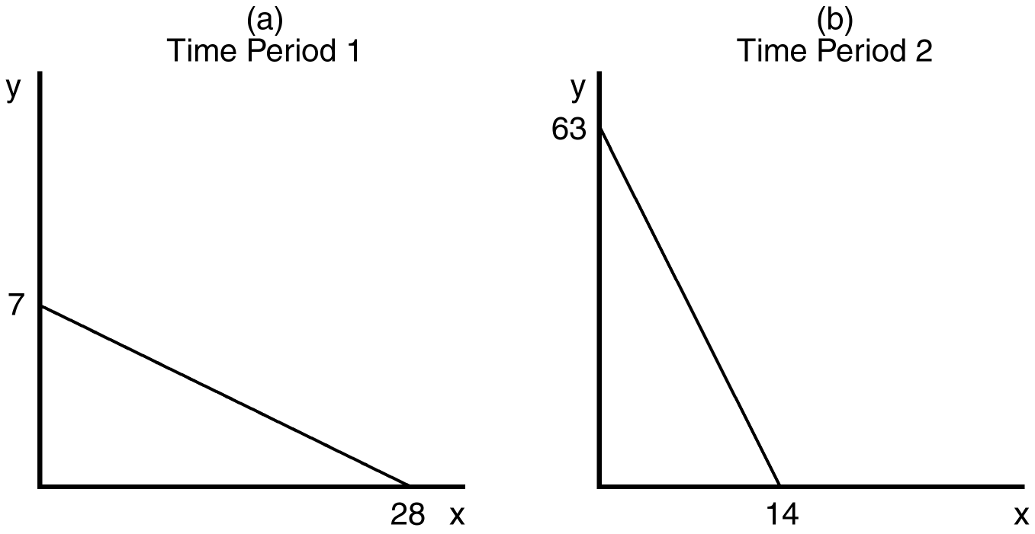
a. Assuming that income is the same on both occasions, describe the difference in relative prices between Panel A and Panel B.
b. If income in Panel B is 126, what is the price of good X?
c. If income in Panel A is 84, what is the price of good Y?
d. Assuming that the price of good X is the same on both occasions, describe the difference in income and price of good Y between Panel A and Panel B.
ANS:
a. The price of good Y is relatively higher in Panel A than Panel B. (Or the price of X is relatively lower in Panel A than Panel B.)
b. $9
c. $12
d. Income in Panel A is twice the income in Panel B, and the price of “Y” in Panel B is 1/18 the price of “Y” in Panel A.
PTS: 1 DIF: 2 REF: 21-1
TOP: Budget constraint MSC: Applicative
4. Evaluate the following statement, “Warren Buffet is the second richest person in the world. He doesn’t face any constraint on his ability to purchase commodities he wants.”
ANS:
Everyone faces scarcity of resources, regardless of how rich they are because wants are assumed to be infinite.
PTS: 1 DIF: 1 REF: 21-1
TOP: Budget constraint MSC: Interpretive
5. List and briefly explain each of the four properties of indifference curves.
ANS:
1: Higher indifference curves are preferred to lower ones, because consumers usually prefer more of something to less of it. 2: Indifference curves are downward sloping. The slope of an indifference curve reflects the rate at which the consumer is willing to substitute one good for another. If the quantity of one good is reduced, the quantity of the other good must increase in order for the consumer to be equally happy. 3: Indifference curves do not cross. If indifference curves did cross, the same point could be on two different curves, thus contradicting the assumption that consumers prefer more of both goods to less. 4: Indifference curves are bowed inward. This is because people are more willing to trade away goods that they have in abundance and less willing to trade away goods of which they have less.
PTS: 1 DIF: 1 REF: 21-2
TOP: Indifference Curve MSC: Interpretive
6. Draw indifference curves that reflect the following preferences.
a. Pencils with white erasers and pencils with pink erasers
b. Left shoes and right shoes
c. Potatoes and rice
d. Income and polluted water
ANS:

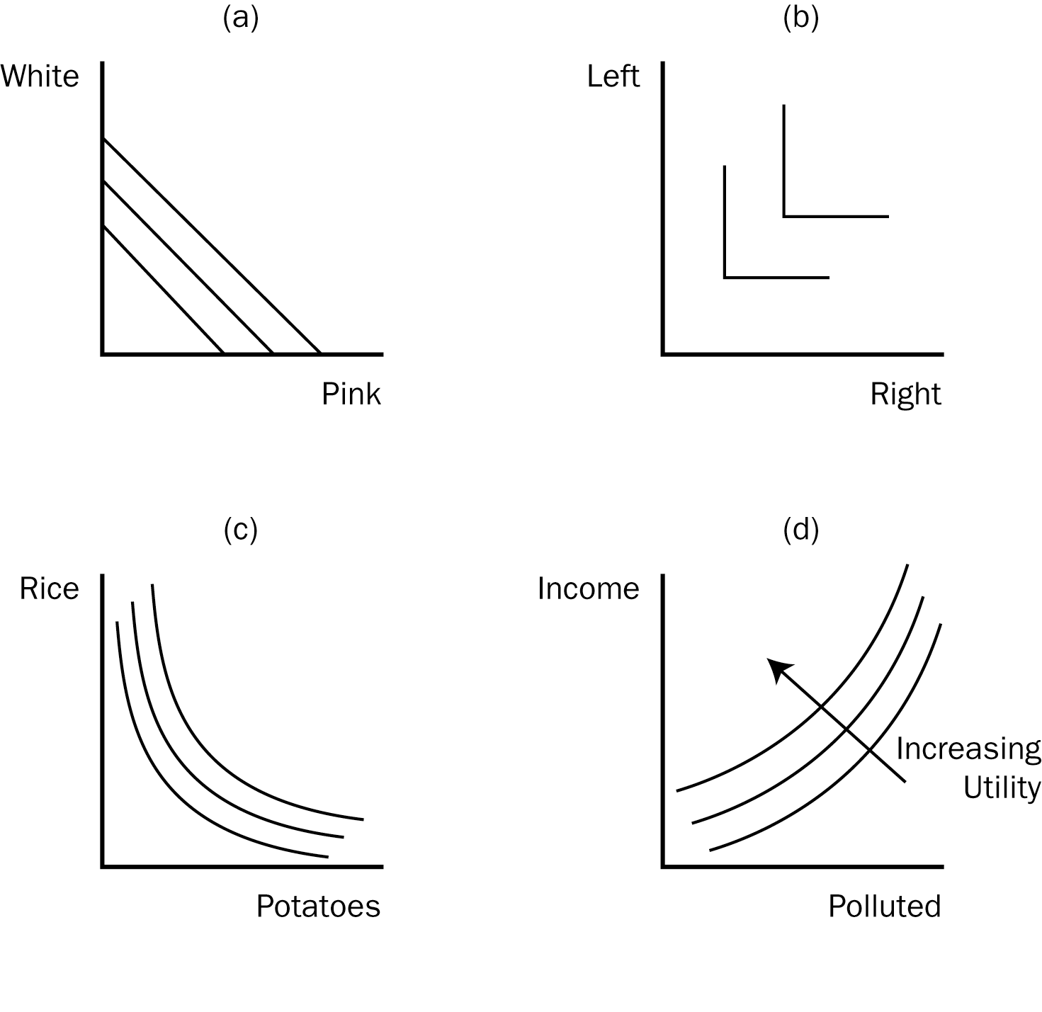
PTS: 1 DIF: 1 REF: 21-2
TOP: Indifference Curve MSC: Applicative
7. Graphically demonstrate the conditions associated with a consumer optimum. Carefully label all curves and axes.
ANS:
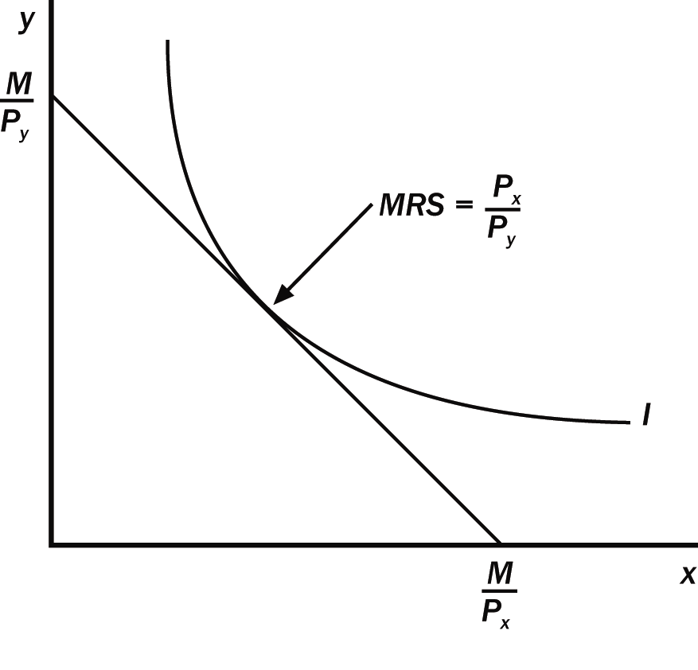
Where M = Income
PTS: 1 DIF: 1 REF: 21-3
TOP: Consumer choice MSC: Applicative
8. Explain the relationship between the budget constraint and indifference curve at consumer optimum.
ANS:
Since the budget constraint is tangent to the indifference curve at the consumer optimum, the slope of the budget constraint (relative market prices) and the slope of the indifference curve (the marginal rate of substitution) are equal.
PTS: 1 DIF: 1 REF: 21-3
TOP: Consumer choice MSC: Interpretive
9. Assume that a person consumes two goods, Coke and Snickers. Use a graph to demonstrate how the consumer adjusts his/her optimal consumption bundle when the price of Coke decreases. Carefully label all curves and axes. What will happen to consumption if Coke is a normal good? What will happen to consumption if Coke is an inferior good? (Remember to explain the possible change when the income effect dominates and when the substitution effect dominates.)
ANS:
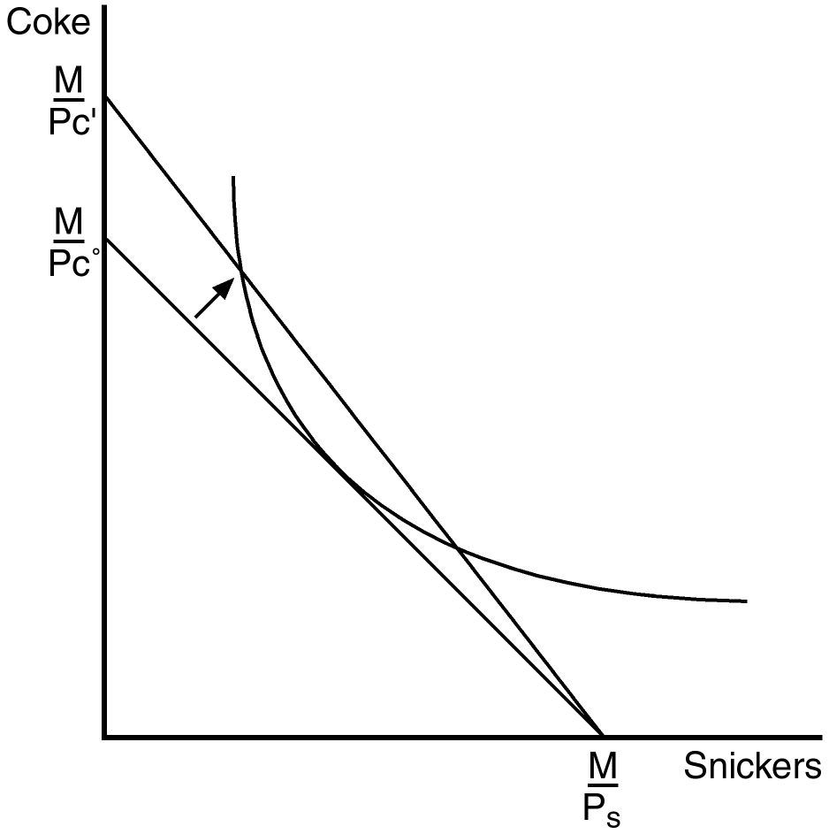
If Coke is a normal good, the consumption of Coke will increase. If Coke is an inferior good and the substitution effect dominates, the consumption of Coke will increase. If Coke is an inferior good and the income effect dominates, the consumption of Coke will decrease.
PTS: 1 DIF: 2 REF: 21-3
TOP: Consumer choice MSC: Applicative
10. Using the graph shown, construct a demand curve for M&M’s given an income of $10.
ANS:
PTS: 1 DIF: 2 REF: 21-3
TOP: Demand MSC: Applicative
11. Evaluate the following statement: “Giffen goods violate the ‘law of demand,’ therefore, the ‘law of demand’ can’t really be considered a ‘law.’”
ANS:
Giffen goods are extremely rare, and so do not provide evidence of a general violation of the logic behind the “law” of demand.
PTS: 1 DIF: 3 REF: 21-3
TOP: Giffen Good MSC: Interpretive
12. Using indifference curves and budget constraints, graphically illustrate the substitution and income effect that would result from a change in the price of a normal good.
ANS:
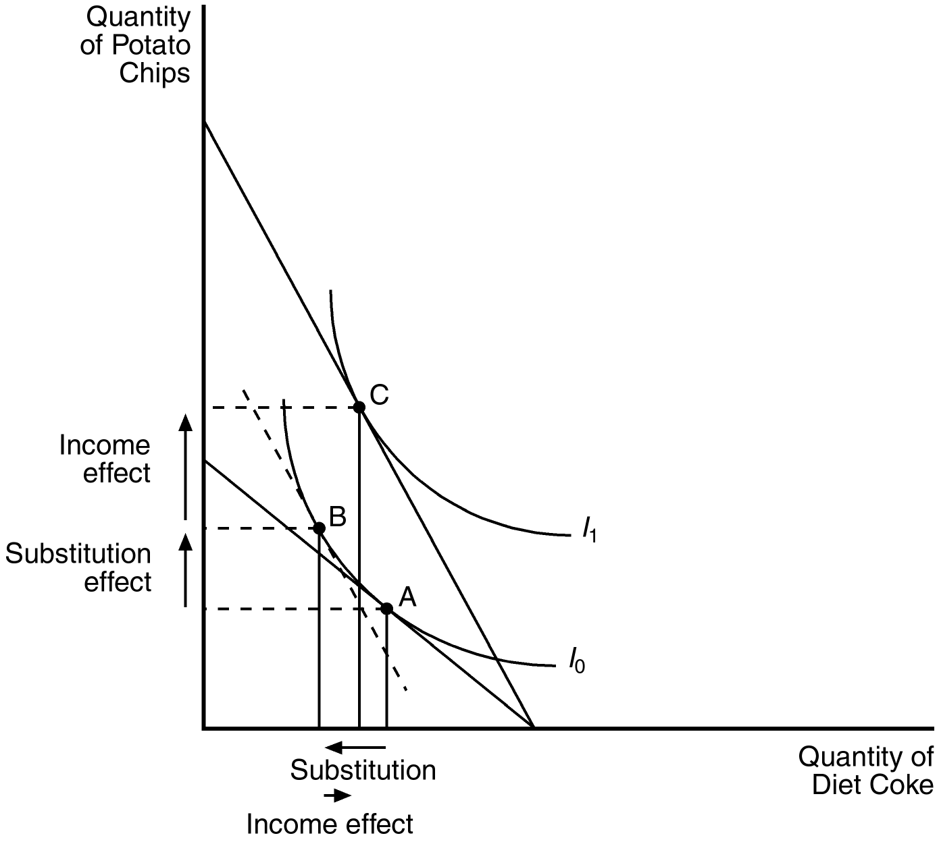
PTS: 1 DIF: 2 REF: 21-3
TOP: Income Effect | Substitution effect MSC: Applicative
13. Explain the difference between inferior and normal goods. As a developing economy experiences increases in income (measured by GDP) what would you predict to happen to demand for inferior goods?
ANS:
Normal goods are those in which consumption is increased as income rises. Inferior goods are those in which consumption is decreased as income rises. We would expect demand for inferior goods to decrease as developing countries experience increases in income.
PTS: 1 DIF: 2 REF: 21-3
TOP: Inferior goods | Normal goods MSC: Interpretive
14. Janet knows that she will ultimately face retirement. Assume that Janet will experience two periods in her life, one in which she works and earns income, and one in which she is retired and earns no income. Janet can earn $250,000 during her working period and nothing in her retirement period. She must both save and consume in her work period and can earn 10 percent interest on her savings.
a. Use a graph to demonstrate Janet’s budget constraint.
b. On your graph, show Janet at an optimal level of consumption in the work period equal to $150,000. What is the implied optimal level of consumption in her retirement period?
c. Now, using your graph from part b above, demonstrate how Janet will be affected by an increase in the interest rate on savings to 15 percent. Discuss the role of income and substitution effects in determining whether Janet will increase, or decrease her savings in the work period.
ANS:
a. see graph below
b. see graph below
c. see graph below
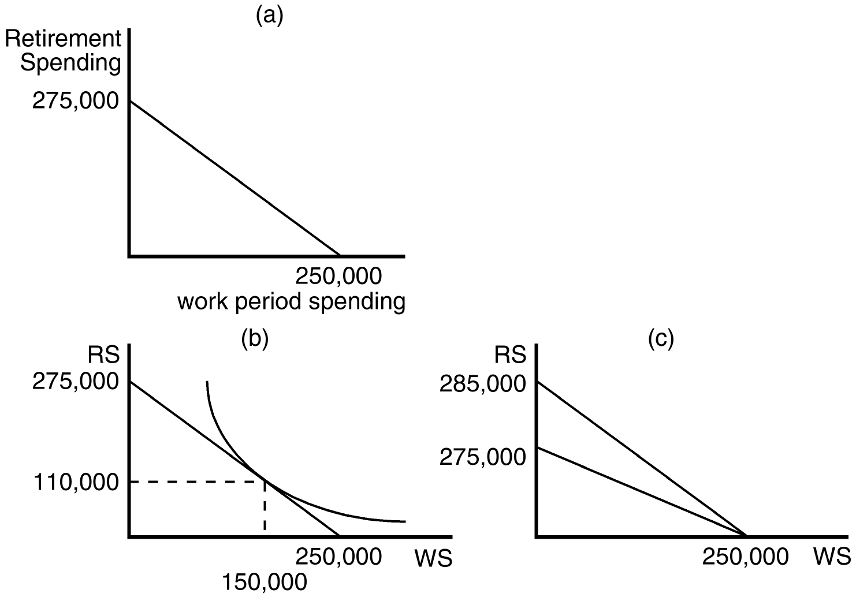
Substitution effect: Retirement spending becomes less costly, so she should increase saving.

Income effect: As income increases she should increase consumption in both periods (thus reducing her saving in the work period.)
PTS: 1 DIF: 3 REF: 21-4
TOP: Consumption-saving decision MSC: Applicative

